**A Project Report on**

**RESUME BASED JOB ROLE PREDICTION**



Submitted in partial fulfillment of the requirements for the award of the degree of

# MASTER OF COMPUTER APPLICATIONS

**SUBMITTED BY**

**BATTULA GANESH**

(23P31F0084)

**Under the Esteemed Guidance of**

**Ms. Rayudu Sowmya, Mca**

**Assistant Professor**



**DEPARTMENT OF MCA**

# ADITYA COLLEGE OF ENGINEERING & TECHNOLOGY

(Approved by AICTE, Affiliated to JNTUK, Kakinada & Accredited by NBA, NAAC with 'A+' grade) Recognized by UGC under the sections 2(f) and 12(b) of the UGC act 1956

SURAMPALEM- 533437, East Godavari District, Andhra Pradesh.

2023-2025

# ADITYA COLLEGE OF ENGINEERING & TECHNOLOGY

(Approved by AICTE, Affiliated to JNTUK, Kakinada & Accredited by NBA, NAAC with 'A+' grade) Recognized by UGC under the sections 2(f) and 12(b) of the UGC act 1956

SURAMPALEM- 533437, East Godavari District, Andhra Pradesh.

2023-2025

**DEPARTMENT OF MCA**



**CERTIFICATE**

This is to certify that the project work entitled, **“Resume Based Job role Prediction”** is a Bonafide work of **BATTULA GANESH** bearing Reg.No: **23P31F0084** submitted to the faculty of Master of Computer Applications**,** in partial fulfillment of the requirements for the award of the degree of **MASTER OF COMPUTER APPLICATIONS** from Aditya College of Engineering & Technology, Surampalem for the academic year 2024-2025.

|  |  |
| --- | --- |
| **Project Guide** | **Head of the Department** |
| **Ms. Rayudu Sowmya, MCA** | **Mr.R.V.V.N.BheemaRao, M.Tech** |
| Assistant Professor, | Associate Professor, |
| Department of MCA, | Department of MCA, |
| Aditya College of Engg & Tech, | Aditya College of Engg & Tech, |
| Surampalem-533437. | Surampalem-533437. |

**External Examiner**

# DECLARATION

I hereby declare that the project entitled **“RESUME BASED JOB ROLE PREDICTION”** done on my own and submitted to **Aditya College of Engineering & Technology, Surampalem** has been carried out by me alone under the guidance of **Ms.Rayudu Sowmya.**

Place: Surampalem Date:

**( B.GANENSH) 23P31F0084**

# ACKNOWLEDGEMENT

The satisfaction and euphoria that accompany the successful completion of any task would be incomplete without the mention of people who made it possible, whose constant guidance and encouragement crowned our efforts with success. It is a pleasant aspect that I have now the opportunity to express my gratitude for all of them.

The first person I would like to thank is my guide **Ms. Rayudu Sowmya., MCA Assistant Professor, Aditya College Of Engineering And Technology, Surampalem,** Her wide knowledge and logical way of thinking have made a deep impression on me. Her understanding, encouragement, and personal guidance have provided the basis for this project. She is a source of inspiration for innovative ideas and her kind support is well known to all his students and colleagues.

I wish to thank **Mr.R.V.V.N.Bheemarao, M.Tech,(Ph.D) Head of the Department, Aditya College Of Engineering And Technology, Surampalem,** has extended his support for the success of this project.

I also wish to thank **Dr.Dola Sanjay S, Principal**, **Aditya College Of Engineering And Technology, Surampalem,** who has extended his support for the success of this project.

I would like to thank all the **Management &Technical Supporting Staff** for their timely help throughout the project.

# ABSTRACT

**ABSTRACT**

Prophesying appropriate job roles based on resume is an important task that involves analyzing different parameters. However, researchers and developers face general challenges in this process. One of the major challenges is the availability and quality of data started again. In some cases, there may not be enough historical or label data to effectively train the machine learning model. Additionally, the available data can be incomplete or incompatible, leading to less reliable predictions.

To resolve these challenges, this project proposes machine learning techniques to predict the role of skilled job based on resumes. To remove these issues, the approach involves collecting data resumed from various sources and databases. The data is then predetermined to remove the discrepancies, remove important information and capture engineer relevant features such as skills, experience and education to capture patterns in job roles. A diverse set of machine learning algorithms, including random forests, decision tree and linear regression, is used to develop a strong future compliant model for job role classification. These models are trained on label resume data and validated using cross-validation methods to ensure reliability and accuracy. By implementing these techniques, the system provides accurate job role recommendations based on the re -introduction material, which helps both the job seekers and the recruiters. The project has been implemented using the Visual Studio Code, in which the python is serving and serving as a backbone to develop and experiment with various machine learning algorithms.

# CONTENTS

#### Chapter 1: INTRODUCTION

# PAGE NO

* 1. Brief information about project 01
  2. Motivation of project 01
  3. The objective of project 02
  4. Organization of project 03

Chapter 2: LITERATURE SURVEY 04

Chapter 3: SYSTEM ANALYSIS

* 1. Existing system 06
  2. Proposed system 05
  3. Feasibility study 07
  4. Functional Requirements 10
  5. Non-Functional Requirements 10
  6. Requirements specification
     1. software Requirements 11
     2. Minimum Hardware Requirements 11

Chapter 4: SYSTEM DESIGN

* 1. Introduction 12
  2. System Architecture 13
  3. Module Description 13
  4. UML Diagrams 13
     1. Use Case Diagram 17
     2. Class Diagram 21
     3. Sequence Diagram 22
     4. Collaboration Diagram 23
     5. Activity Diagram 25

Chapter 5: TECHNOLOGY DESCRIPTION

* 1. Introduction to python 26
  2. Introduction to machine learning 34

Chapter 6: SAMPLE CODE 60

Chapter 7: TESTING

* 1. Introduction 61
  2. Sample Test Cases Specification 64

Chapter 8: SCREENSHOTS 67

CONCLUSION 77

BIBILIOGRAPHY 78

### LIST OF TABLES

**S.NO TABLE NO NAME OF THE TABLE PAGENO**

1. 4.5.1.1 Use Case Template for data acquisition 17
2. 4.5.1.2 Use Case Template for data preprocessing 17
3. 4.5.1.3 Use Case Template for joint detection 18
4. 4.5.1.4 Use Case Template for feature extraction 19
5. 7.2.1 Sample Test Case Specification 64

**LIST OF FIGURES**

**S.NO FIGURE NO NAME OF THE FIGURE PAGENO**

|  |  |  |  |
| --- | --- | --- | --- |
| 01 | 4.1 | System Architecture | 13 |
| 02 | 4.4.1 | Use case Diagram | 17 |
| 03 | 4.4.2 | Class Diagram | 21 |
| 04 | 4.4.3 | Sequence Diagram | 22 |
| 05 | 4.5.1 | Collaboration Diagram | 23 |
| 06 | 4.5.2 | Activity Diagram | 25 |

**LIST OF SCREENSHOTS**

|  |  |  |  |
| --- | --- | --- | --- |
| S.NO | SCREEN NO | NAME OF THE SCREEN | PAGENO |
| 01 | 8.1 | Set the path to execute | 67 |
| 02 | 8.2 | Execute the main code | 68 |
| 03 | 8.3 | Executed in Browser | 69 |
| 04 | 8.4 | User interface 1 | 70 |
| 05 | 8.5 | User interface 2 | 71 |
| 06 | 8.6 | Result page2 | 72 |
| 07 | 8.7 | Result page3 | 73 |
| 08 | 8.8 | Result page4 | 74 |
| 09 | 8.9 | Result page5 | 75 |
| 10 | 8.10 | Result page6 | 76 |

# CHAPTER 1 INTRODUCTION

1. **INTRODUCTION**

#### Brief introduction about the project:

The resume-based job rolls are focused on analyzing resumes to predict appropriate job roles using advanced machine learning techniques. The project includes various stages, including data collections, preprosasing, feature extraction and model development, such as random forest, supprort vector machine (SVM), linear region and algorithms such as algorithm. These models are trained to analyze major re -initiated features including skills, experience, education and industry domains, so that candidates can be accurately classified into relevant job categories. This documentation provides a structured observation of objectives, system functionality, challenges, and methods of evaluation to ensure reliability and accuracy in the role classification of job. The project enhances the hiring process by taking advantage of re-starting data reprising, verification technology and machine learning-powered insights, by offering the project automatic and accurate job role recommendations. It benefits both job seekers by streamlining candidates selection by aligning appropriate career opportunities and employers, by reducing manual screening efforts and improving overall recruitment efficiency. In addition, the project discovers innovative convenience selection methods, model adaptation strategies and real-time job recommendation approaches, which contribute to progress to workforce analysis and AI-operated recruitment solutions. The ultimate goal is to create a wise and scalable tool that re-starts evaluation and the prediction of the role of the job, which is more efficient, data-powered and impartial work.

#### Motivation of project:

The inspiration behind the documentation of the resume-based job roll prediction machine learning project stems from its important role in pursuing knowledge conservation, effective communication and AI-operated career prediction systems. By making a structured and comprehensive record of project objectives, functioning, functionality and results, documentation ensures that the valuable insights obtained during the development process systematically transferred future researchers, developers and professionals of the industry. Transparent and well -maintained documentation machine enhances copy of a copy and scalability of the learning model, facilitates further studies and the role of job role and facilitates continuous improvements in automated recruitment systems. It also plays an important role in accountability and decision making, the clear understanding of the functioning, faced challenges, and the solution was implemented. In addition, it acts as an educational resource for both both technical and non-technical audiences, which increases awareness about AI and machine learning that it can revolutionize the processes of working and career recommendations. Beyond academic and technical contribution, the project promotes innovation in recruitment technology, empowering organizations with data-carved strategies that reduce manual efforts and improve candidates and reviews. For job seekers, it provides AI-operated career guidance, which helps them to identify the appropriate career paths based on their skills, experience and industry trends. Finally, the project contributes to the development of automated, intelligent and fair recruitment systems, which paves the way for a more efficient and inclusive job market.

#### Objective of the project:

The resume-based job roll prediction machine learning project aims to accurately analyze the resume and to take advantage of advanced computational techniques to make the resumes accurate analysis and predict suitable job roles for candidates. Using state -of -the -art machine Learning algorithms, the project tries to develop models that effectively remove, procedure and evaluate major re -beginning components such as skills, experiences, education and industry domains to classify candidates in relevant job categories. This automation reduces dependence on manual resume screening, enhances recruitment efficiency, and improves the matching of candidates by ensuring that applicants are aligned with roles that are best suited for their merit and expertise.

Additionally, the project focuses on re-starting data-making decisions in recruitment by re-starting data and generating meaningful insights. It examines advanced facility selection techniques and optimizes machine learning models to improve predicted accuracy and performance. Another important aspect is the development of a real -time job recommendation system, which ensures dynamic and individual job suggestions based on the removal resumed information. In addition, project workforce contributes to analytics and career insight, helping job seekers understand potential career paths and help employers in the workforce plan.

By integrating techniques such as natural language processing (NLP), supervised Learning algorithms (SVM, Random Forest, XGBOST, etc.), and domain-specific data analysis, the project aims to change traditional recruitment workflow. The ultimate goal is to create a strong, scalable and AI-operated recruitment assistant that enhances job matchmaking, reduces prejudices in hiring, and recruiting the recruitment life cycle, both benefit from the jobs.

* 1. **Orgainazation of the Project:**
* **Literature survey:**This Chapter consists of background of background of the project and possible approchs ,intro and comparison.
* **System analysis:**The descriptionof the current system, the planned system the requiremenst make up the majority of this chapter.
* **System Disign:** This is consists of modules disscription and algorithms with example and use diagram ,class diagram, secquence,collaboration diagram and activity diagram.
* **Technology Description:**This chaptermainly consists of the technology description of this project.
* **Sample code:** This chapter consisting of sample code for the few madules.
* **Testing:** This chapter is mainly consisting of testing techniques and test cases for modules.
* **Screenshots:** This chapter is mainly consisting of output screens of this project.
* **Conclusion:** Main Conclusion of thr project is to segmentation the customer based on characteristics.

# CHAPTER 2 LITERATURE SURVEY

1. **LITERATURE SURVEY**

### 2.1 Resume based job role prediction using machine learning technique:

In today's competitive job market, accurately classifying job roles based on resumes, is an important task for both recruitments and job seekers. Re -starting classification includes various resume characteristics, such as skills, experiences and education analyzing the most suitable job role for a candidate. Machine learning technology has proved to be effective in automating this process by removing relevant information and maping it in predetermined job categories. The primary objective of this research is to examine machine learning-based techniques for classification of job role and obtain the best accuracy in prediction. The dataset consists of resumes with label job roles, and analysis involves several machine learning techniques, such as support vector machine (SVM), random forest and linear regression, to classify resumes in appropriate job roles. The dataset undergoes preprosasing, including variable identity, universariate and multicarete analysis, handling missing values ​​and convenience selection. The withdrawn features, such as skills and experiences, are used to train the machine learning models, which are then evaluated on the basis of accuracy, accurate, recall and F1-score. Classification results help understand how well each model performs in predicting job roles. This research compares the effectiveness of various machine learning algorithms by analyzing confusion matriasis and classification reports. Conclusions display machine learning ability to increase automatic job matching and improve the efficiency of the recruitment process. The proposed machine learning-based approach provides a customized solution for the job role classification by ensuring high accuracy in predictions.

#### Job Role Prediction Using Machine Learning

The main goal of this project is to use machine learning techniques to predict appropriate job roles based on resumes. The prophecy of the job role is an important task in the recruitment process, as it helps the candidates to match with the most relevant positions based on their qualifications and skills. This study used the following re -introduced characteristics to assess job suitability: skill, education, year of experience, job description, certificate and domain expertise. These features are extracted and used as input for classification. To estimate the most appropriate job role, paper appoints three classification algorithms: support vector machine (SVM), Random Forest (RF), and Layer Recovery (LR). Various industries were used using real -class re -beagining dataset, as well as additional synthetic data based on standard job role distribution. Depending on the results of various classifier, it was found that the support vector machine (SVM) classifier improves other models in terms of accuracy and generalization capacity. The study conclusion that machine learning approaches are automatically effective for predicting job role, both of them improving the process of hiring and job matching efficiency.

### Resume based job role prediction using random forest

This paper examines the use of machine learning algorithms to predict appropriate job roles based on resumes. The model is trained on a re -launched dataset which includes major features such as skills, education, year of experience, job description and certificate. The classification algorithms used in this study include random forest (RF), support vector machine (SVM), and linear regression (LR). Additionally, hypertime tuning was performed on random One classifier using grid search techniques to optimize accuracy. Among the models tested, random forests improved others with highest accuracy, demonstrating its effectiveness in job role classification. These findings highlight the ability of machine learning in automatic and improving job matching processes in the recruitment industry.

.

# CHAPTER 3 SYSTEM ANALYSIS

1. **SYSTEM ANALYSIS**

### EXISTING SYSTEM

In the field of predicting job role based on resumes, researchers and developers face many challenges. One of the major issues is the availability and quality of the labeled data resumed. Many resumes lack a standardized format, making it difficult to remove structured information such as skills, education, experience and industry domains. Additionally, resumes often have irrelevant or fruitless text, which requires advanced natural language processing (NLP) techniques to effectively filter and analyze meaningful materials. Another important challenge is dependence on manual job roll classification, often subjective and inconsistent. The traditional recruitment system mainly depends on the keyword-based matching, which fails to accurately interpret the merit of a candidate in the context. This approach does not consider semantic relations between skills and job roles, causing predictions of wrong or irrelevant jobs. In addition, the traditional system struggles with domain-specific variations, summarization and vague terminology, further prediction accuracy. These limitations highlight the inability of existing recruitment methods, which depends a lot on manual efforts and lacks intelligent data processing capabilities. Consequently, advanced machine learning models require a pressure that can be adapted to various re -start structures, can remove relevant information more effectively, and the job role can improve classification accuracy. By overcoming these challenges, the AI-operated recruitment system can increase automation, accuracy and efficiency in job matching, which can lead to better work for both job seekers and employers.

**DISADVANTAGES:**

* Traditional job-matching systems rely on simple keyword matching, leading to inaccurate job predictions.
* Resumes come in unstructured formats (PDFs, DOCs, images), making automated processing challenging.
* Manual job classification is time consuming and prone to human error.
* Older systems struggles to integrate with modern machine learning and NLP tools.
* Lack of real-time learning leads to outdated job role recommendations.

### PROPOSED SYTSEM

I am developing a smart system that predicts appropriate job roles based on resumes using machine learning techniques. The system improves the accuracy of the job role classification by taking advantage of advanced algorithms such as random algorithms such as random forests, support vector machines (SVMs), and linear regression. The implementation of these machine learning models ensures adaptive and accurate predictions by continuously learning from newly started data. The system processes large versions of data that resumes data efficiently, extracts key features such as skills, experience and education to provide recommendations of the exact job. algorithms such as random forests, support vector machines (SVMs), and linear regression. The implementation of these machine learning models ensures adaptive and accurate predictions by continuously learning from newly started data. The system processes large versions of data that resumes data efficiently, extracts key features such as skills, experience and education to provide recommendations of the exact job. Additionally, the system is designed to be a user friendly, making it accessible for the least technical knowledge to the recruiters or job seekers. The proposed system provides a scalable, automatic and cost -effective solution for classification of job role, improves the process of hiring manual efforts and keeping accuracy by increasing accuracy.

**ADVANTAGES:**

* Accurate job role predictions by analyzing multiple resume attributes.
* Seamless integration with modern machine learning frameworks for improved performance.
* Scalability to handle large resume datasets across difficult industries.
* Enhanced security to ensure data integrity and system reliability.

#### Feasibility Study

A feasibility study to predict a resume-based job role involves evaluating the feasibility, effectiveness and stability of applying machine learning models to classify job roles on the basis of re-introduced data. This study examines several aspects, including technical, economic and operational feasibility to determine the practicality of deploying the system in real -world recruitment processes.

Pactivity studies indicate that a re-launched job role prediction system is viable from economic, technical and operating perspective. This cost provides significant benefits such as cost savings, better hiring accuracy, reduced manual efforts and AI-operated career insights. By taking advantage of machine learning models, NLP and cloud computing, the project ensures that job seekers are matched with appropriate roles to increase data-operated hiring decisions for employers. The study valid the practicality and efficiency of implementing the system in modern recruitment workflows.

* Economic Feasibility
* Technical Feasibility
* Operational Feasibility

### ECONOMIC FEASIBILITY

The An economic viability is analyzed by considering the development of perspective, the development of the financial viability of the system, considering the implementation and maintenance costs. Expenditure includes the ongoing costs for machine learning models, NLP tools, cloud infrastructure and API integration -the ongoing costs for updates, performance monitoring and safety growth. However, by reducing system hiring time, manual resume screening is leading to efficiency and cost savings in recruitment by reducing the manual resume screening efforts, and by improving the candidate-Job matching accuracy. In terms of technical viability, the study checks whether the technology, algorithms and infrastructure required for successful implementation are available. The system requires access to high-quality-labeled resume datasets for model training and natural language processing (NLP) techniques should be able to handle various re-start formats (PDF, DOCX, TEXT) when applying natural language processing (NLP) techniques to remove skills, education and experience. Machine learning models such as support vector machines (SVMs), random forest, linear regression, and XGBost are employed for classification, while deep learning models such as burt and transformer-based architecture can increase the accuracy of re-learning models. Additionally, integrating APIs such as Google API, facial models, dandelion APIs, and Gemini APIs ensure efficient text extraction, skill conclusions and domain-specific insights ensure. The system should also have scalable and high performance to provide computational power required to efficiently process cloud-based solutions such as AWS, Google Cloud, or Azure.

### TECHNICAL FEASIBILITY

The Technical feasibility assessment for re-starting job role prediction evaluates the practicality of applying machine learning models for accurate and efficient job role classification. The system takes advantage of advanced algorithms such as random forest, support vector machine (SVM), linear regression, and XGBost, which processes large versions of data, removing relevant features (skills, experiences, education, industry domains) and predicting the most appropriate job roles. By conducting a comprehensive technical feasibility study, the system ensures spontaneous integration with modern recruitment platforms and enables real -time processing of resumes in various formats including PDF, docx and TXT.

To increase accuracy, the system employs natural language processing (NLP) techniques for text extraction, convenience selection and classification. NLP methods such as nominated entity recognition (NER), part-off-speech (POS) tagging, and burt-based embeding are applied to extract structured data from unarmed resume text, which ensures accurate understanding of the qualifications of the candidates. Additionally, deep learning models such as transformers and burts can be included to improve understanding of resume, allowing the system to interpret reference beyond simple keyword matching.

The system is designed for high scalability and adaptability, making it suitable for various industries and job domains. To ensure high-demonstration computing and storage capabilities, AWS, Google Cloud, or Microsoft Azure can take advantage of cloud-based solutions such as AWS, Google Cloud, or Microsoft Azure and can handle the resumed processing efficiently on a large scale. In addition, the system is designed to follow data privacy and safety standards, including GDPR and industry-specific rules, designed to ensure the safety and moral handling of sensitive user information, including regulations.

### OPERATIONAL FEASIBILITY

Operating An operational feasibility approach, assesses the study, assesses whether the system can be effectively adopted and integrated into recruitment processes. A major factor is ensuring a user -friendly interface, allowing HR professionals, recruitments and job seekers to easily interact with the system. Applying a streamlined-based UI can re-introduce the prevention and visualization of analysis results. Additionally, the system should significantly reduce manual efforts in re -start screening, allowing HR teams to focus on interviewing and hiring the best candidates. To ensure reliability, the machine learning model must receive high prediction accuracy, and regular updates will be required to develop job market trends. In addition, the system should basically integrate with the current applicant tracking system (ATS) and HR software, ensuring compatibility with corporate hiring workflows.

In the end, feasibility studies assume that a re-launched job role prediction system is feasible in terms of economic, technical and operational feasibility. It provides significant benefits, including cost savings, better hiring accuracy, reduced manual efforts and AI-powered career insights. By taking advantage of machine learning, NLP and cloud computing, the system ensures that job seekers are matched with relevant roles by increasing data-operated hiring decisions for employers. This viability assessment confirms that implementing such a system would be a practical and efficient solution for modern recruitment challenges.

### FUNCTIONAL REQUIREMENTS

System functional requirements describes activities and services that must provide:

* Extract and process resume data ,including key parameters such as skills, experience, education, and certifications.
* Apply natural language processing (NLP) techniques to analyze and extract relevant features from resumes for machine learning models.
* Develop and deploy machine learning algorithms such as random forest, SVM and linear regression for classification of accurate job.
* Enable real -time updates to prediction models, ensure adaptability to develop job market trends and resume structures.
* Design the system for scalability, allowing it to handle large dataset and increase user demands as the recruitment process expands.
* Create a user -friendly interfaces for uninterrupted interactions, enable recruiters and job seekers to imagine the role of jobs and insight.

### NON-FUNCTIONAL REQUIREMENTS

* Ensure that the system can handle a specified number of concurrent users and data points without significant performance declines.
* Ensure system display efficiency, it allows to handle large versions of concurrent users and re -handle data without significant delays. And the guarantee system reliability and uptime continuous availability with minimal downtime for spontaneous user experience.
* Support scalability, allows the system to adjust the increasing dataset and increase the increasing number of recruitors and job seekers.
* Develop a spontaneous user interface, making it easy and easy to use for individuals with different levels of technical expertise. And implement strong safety measures, protecting sensitive user data, including resumes and job recommendations, by unauthorized access and violations.
* Define the acceptable levels of accuracy and accuracy for machine learning models, ensure optimal performance and alignment with recruitment industry standards.

### REQUIREMENTS SPECIFICATION

#### Hardware Requirements:

Processor : 2.0 GHz or above

RAM : 8 GB min

HDD : 500 GB

#### Software Requirements:

Operating System : Windows 10

Technology : Python 3.10

IDE : visual studio code

# CHAPTER 4 SYSTEM DESIGN

### . SYSTEM DESIGN

#### 4.1 Introduction:

The purpose of the design phase is to develop a structured solution based on the document of the requirements. System design involves defines architecture, components, modules, interfaces and data flow to ensure efficient implementation in system design. It translates functional and non-functional requirements into a streamlined outline that facilitates smooth deployment.

A well -defined system design plays an important role in achieving accurate and efficient job role using machine learning techniques. A resume-based job roll prediction system using machine learning requires an integrated approach to designing a several components to ensure accurate classification. The system mainly focuses on processing resumes, extracts relevant features, and predicts appropriate job roles based on key features such as skills, experience, education and certificate.

The first phase involves data collection and preprocessing, where resumes are assembled from diverse sources and cleaned to remove discrepancies. Natural language processing (NLP) techniques are applied to extract significant information, tokens of text and handle the missing data. Additionally, feature engineering raw re -introduced text is done to convert the text into a structured numerical representation that increases the classification accuracy. The origin of the system is its machine learning model. The support vector machine (SVM), Random Forest (RF), and Linear Recovery (LR) are used to analyze patterns and classify resumes in relevant job roles.

Clothing techniques can be used to increase model performance. The system is trained at a diverse dataset that has resumes from various industries, ensuring the ability to generalize in various job sectors. The effectiveness of models is evaluated by using cross-validation.  
 The first phase includes data collection and preprosasing, where resumes are collected from various sources, including job portal, recruitment database and company HR systems. Preprocessing phase includes cleaning resumes by removing discrepancies, handling missing data and standardizing formats. Natural language processing (NLP) techniques such as Tokenization, designated unit recognition (NER), and lametization are applied to extract meaningful information, to break text data in structured tokens and eliminate fruitless or irrelevant details. Additionally, feature engineering is done to convert raw text data into structured numerical representations, the classification increases accuracy.

The first phase includes data collection and preprosasing, where resumes are collected from various sources, including job portal, recruitment database and company HR systems. Preprocessing phase includes cleaning resumes by removing discrepancies, handling missing data and standardizing formats. Natural language processing (NLP) techniques such as Tokenization, designated unit recognition (NER), and lametization are applied to extract meaningful information, to break text data in structured tokens and eliminate fruitless or irrelevant details. Additionally, feature engineering is done to convert raw text data into structured numerical representations, the classification increases accuracy.

### SYSTEM ARCHITECTURE:

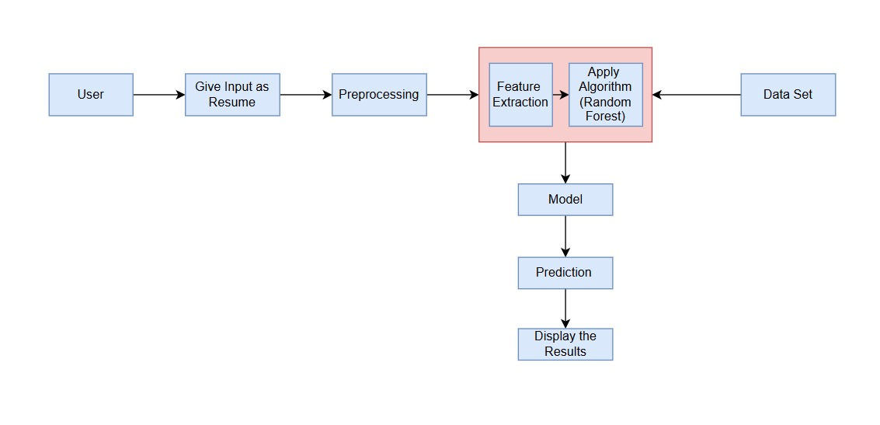

#### Architecture Description:

Designing architecture to predict the role of a re -start -based job using random forest involves orchestrates various components to create a strong and efficient structure. At the core of architecture is a random forest algorithm, a troop of a powerful artists is famous for its effectiveness in classification tasks.

### 4.2 MODULE DESCRIPTION:

**Data Collection and Preprocessing:** The The first step in the resume-based job roll prediction includes a comprehensive dataset that includes information related to resumes, job descriptions and relevant career. Dataset contains key features such as skills, work experience, education, certificate and job title. To ensure stability and reliability, data passes through a series of pre -processing stages including data cleaning, generalization and feature engineering.

**Feature Selection and Engineering:** For predicting the role of a resume-based job, domain knowledge and statistical techniques are applied to identify the most impressive characteristics that affect the job role classification. Feature selection ensures that only the most relevant variables include, models improve efficiency and performance. By implementing convenience selection and engineering, the model enhances its ability to make accurate prediction of job roles based on resumes, improve accuracy accuracy and reduce computational complexity

**Deployment and Integration:** After verification, trained re-launched job role prediction models are deployed in a production environment, ensuring access and scalability. The pepsinogen process involves integrating the model in a user friendly application or API, which enables recruitments, HR professionals and job seekers to interact basically with the system. Ensuring efficient deployment and integration, again becomes a powerful tool for the restless job role prediction system career guidance, talent acquisition and job market analysis

**Monitoring and maintence:** Monitoring of continuous of deployed model very ensure relability and over time**.** The tools are bethe models performenace metrics and alerts stakeholders to any deliveres to eith updated data and fine tuning of para meters to adopt the changing the conditions.

#### UML Diagrams

Uml defines as unified mmodiling language it allows the software engineer to express thr analysis model using modeling notation that is a governed by a set of pragamatic rules.

The various moduling techniques are there in market to evolve this ums concept.those are different angles are used to show it . in a uml is build using two distent domains. Behavioural moduling implementation modeling ,and structural model views and environmental model views are the focus of uml desing modeling,

Unified Modeling Language (UML) provides a standardized approach to software engineers, which provides a standardized approach to imagination, specified, construction and document of the software system. It enables engineers to express an analysis model, which using a graphical notation ruled by a well -defined set of syntax, meaning and practical rules.

UML plays an important role in object-oriented system development, allowing teams to design complex systems with clarity and stability. To provide a comprehensive understanding of the system, the UML uses five different ideas, represents different aspects of each software architecture.

The user model view focuses on how the end-users interact with the system, usually illustrated through case diagrams. Structural model defines the static structure of the system using visual class diagrams, object diagrams and component diagrams, which help model relationships between system components. The behavior model views shows how the system behaves over time using sequence diagrams, activity diagrams and state machine diagrams, capture interactions and workflows.

The UML is roughly classified into two main domains: UML analysis modeling, which focuses on user models and structural model ideas, which helps define business requirements, system architecture and functional specifications, and UML design modeling, which emphasizes behavioral modeling, implementation modeling and environmental modeling, ensures that software design and ensures that software design and ensures that software design and ensures that software design and ensures that software design.

The various uml diagrams that categorized in the below them.

* Use case diagram for system
* Class diagram for system
* Secquence diagram for system
* Collaboration diagram for system
* Activity diagram for system

#### Use Case Diagram

Use Case diagrams for an resume based job role prediction System describes the system offered the key functions, the external users or actors that connect with it, and the relationships between them. These diagrams help capture the system higher accuracy of job role prediction using Machine Learning Algorithms 13 functional specifications while the analysis state of development. The main objectives are to visualize what the system is expected to do, identify the different types of users—such as environmental analysts, data scientists, or public users—and outline how they interact with system features.

Visual Notation: The System Actor, the Use Case, and the Association are the elements that make up a Use Case diagram.

|  |  |  |  |
| --- | --- | --- | --- |
| **Actor** | If we call as an actor ,is a user and is depicted using a stick figure. that represents a user within the system. The role of the user is displayed beneath the image. Nonhuman entities can also be actors. When an application interacts with another application, it can also take on the role of an actor by anticipating input or producing output. | **Actor Role Name** | |
| **Use Case** | A use case highlights the goals of the user and shows how they interact with the system. Use cases are usually displayed as ovals. Within these ovals is the name of each use case | **Use Case Name** | |
| **Directed Association** | An association is a communication relationship that is used to manage an actor's involvement in a use case, such as starting a system function. It is shown as a straight line or a line with an arrow in a use case diagram. |  |  |
|  |

#### Actor:

In unified modeling languages ,is an actor side role p;ayed by a user ,system si used for entity that interact wirth a software system. Actors are used to describe the different types of entities or users that interact with the system under design. They might initiate or participate in one or more use cases. Actors are frequently depicted as stick figures in UML diagrams.

#### Use Case:

A use case explains how a system works in a certain way to provide a definite result. It describes a sequence of actions performed by the system, including interactions with users or other components. Use cases assist in determining and illuminating the functional requirements of the system from the perspective.

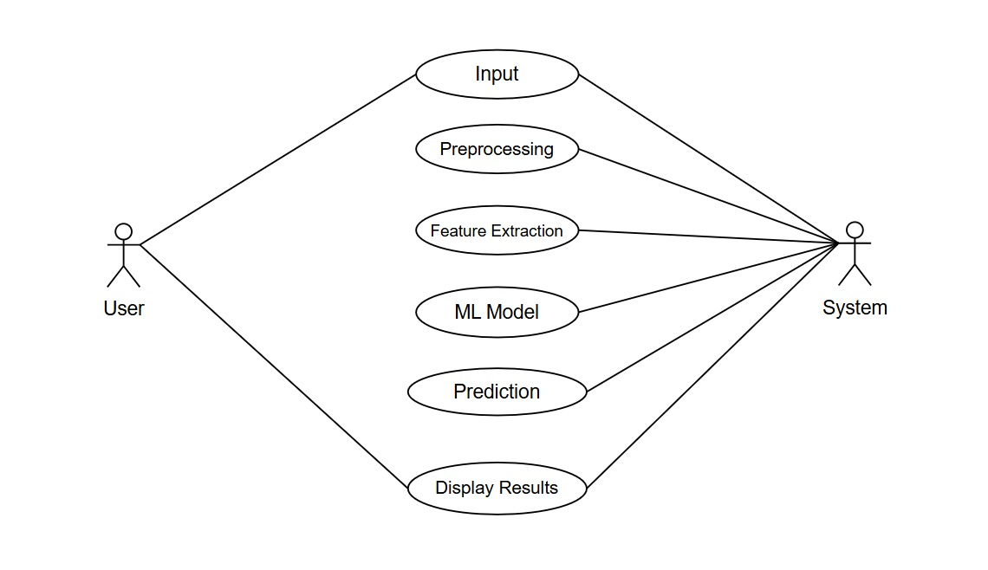

## Fig 4.5.1 Use Case Diagram for system

#### Description:

In the above diagram represents that usecase diagram of the project is use contain data collecting ,data preprocessing,data claiming and model evalution and learning the model.

##### Use Case Templates:

|  |  |
| --- | --- |
| **Use case name** | Upload Resume |
| **Participation actors** | Machine learning system |
| **Flow events** | User should read the input resume  Ml system is performing the data preprocessing |
| **Event condition** | System should collect the sataset from the user at ml system |
| **Exit condition** | System will successfully processed all data set |

**Table 4.4.1.1: Use case template for Data Acquisition**

|  |  |
| --- | --- |
| **Use case name** | Data Preprocessing |
| **Participation actors** | Machine learning system |
| **Flow events** | * Ml system is resolved the noie and the data is issued by the building model. * Ml system is perform scalings to make the model is work precisely and effictly |
| **Entry condition** | ML system is preprocessing the data |
| **Exit condition** | ML System successfully select the feature. |

##### Table 4.4.1.2: Use case template for Data Preprocessing

**Data table for Text Extraction**

|  |  |
| --- | --- |
| **Use case name** | Text Extraction |
| **Participation actors** | Machine learning system |
| **Flow events** | * ML System should detects the skills from the resume. * The ML system ought to identify the precise location of the hand's joints |
| **Exit condition** | ML System should preprocess the dataset. |

|  |  |
| --- | --- |
| **Use case name** | Feature Extraction |
| **Participation actors** | Machine Learning System |
| **Flow events** | * ML system is having the noice data to build a model * Ml system perform numerical codeing to make model work effectively |
| **Entry condition** | the dataset should be preprocessed by the ML system |
| **Exit condition** | The features are successfully chosen by the ML System |

**Table 4.4.1.4: Use case template for Feature Extraction**

|  |  |
| --- | --- |
| **Use case name** | Job Role Prediction |
| **Participation actors** | Machine Learning System |
| **Flow events** | * The data is used to create the proper model, and the ML system should eliminate noise.   • Gray scaling will be done by the ML system to ensure that the model operates accurately and efficiently |
| **Entry condition** | the dataset should be preprocessed by the ML system |
| **Exit condition** | The features are successfully chosen by the ML System |

**Table 4.4.1.5: Use case template for Arthritis Detection**

* + 1. **Class Diagram:**

In an resume based job role prediction System, the class diagrams outline the system's structure by defining key classes, their attributes, methods, and relationships. Main classes include Sensor Data for environmental inputs, Data Preprocessor for cleaning and transforming data, Forecast Model for training and prediction, User Interface for interaction, and Database Manager for data handling. These classes are connected through associations and inheritances, providing a clear blueprint of system functionality and supporting efficient, maintainable development

|  |  |  |
| --- | --- | --- |
| **Class** | Classes in a UML class diagram are the most widely represented elements. These classes are typically grouped together in a class diagram to define the static relations between the objects involved. A class is depicted in a box that is divided into three sections: the name of the class is placed in the top section; the middle section contains the attributes; and the bottom section contains the methods the class can perform. |  |
| **Association** | If two classes within a model must communicate with each other, the connection must exist between them; this connection can be shown as an association. Associations are presented in a class diagram as lines between the classes, where the arrow indicates the direction of navigation. |  |

**Graphical Notation**:.in graphical notation classes and relationships between them.

**Class:** A Class is a building block in OOPL.

Classes are building blocks in object- oriented programming language. A is a anthe class is depicted using a rectangle divided into three section.

The top section is name of class, the middle section defines the properties of class. The bottom section list the methods of the class.

**Association:** An accession illustrated by a line linking them in a class diagram. This connection can be labeled to explain the role of the relationship and may include multiplicity indicators, such as one to one (or) one to many, to define how many instances of each class are involved in the relationship

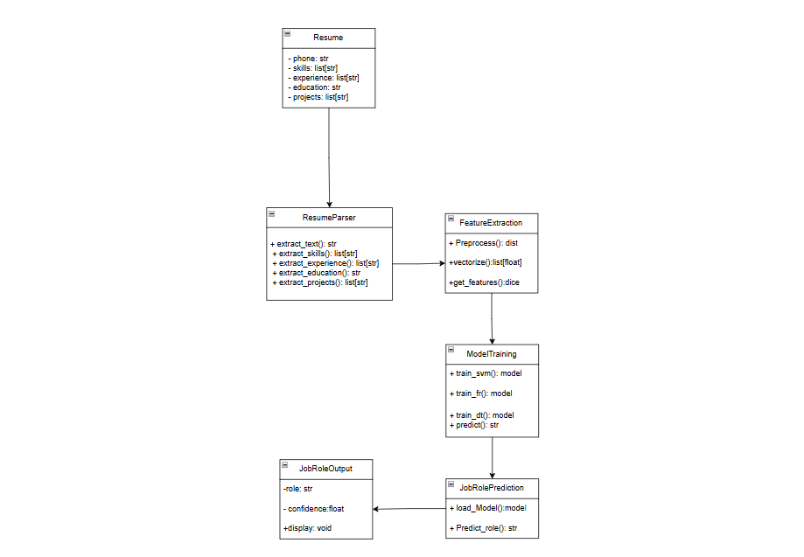

#### Fig 4.4.1: Class diagram for System

**Description:**

The class diagram for the project that used job role prediction is shown in the diagram above. The project's processes are shown, including how to upload a dataset, read it, pre-process it, and use machine learning methods to build the model.

#### Sequence Diagram:

Sequence diagrams visually represent the interactions between objects to accomplish a specific outcome, often related to a use case. In the context of UML,which is designed for object-oriented programming, these interactions are termed as messages. Sequence diagrams organize objects horizontally and track time vertically, illustrating the flow of messages over time.

Visual Representation: Sequence diagrams display objects and actors as columns, with vertical lifelines marking the object's existence throughout the process.

Object: Objects are specific instances of classes, arranged horizontally across the diagram. They are depicted as rectangles, optionally labeled with an object name followed by a colon and the class name.

Lifeline: A lifeline represents the duration of an object's existence. It's shown as a upward dashed line extending from the object.

Activation: Rectangular boxes along the lifeline show activations, which are times when the object is actively carrying out an action.

Message: The communication flow between objects is represented by messages, which are shown as horizontal arrows between activations.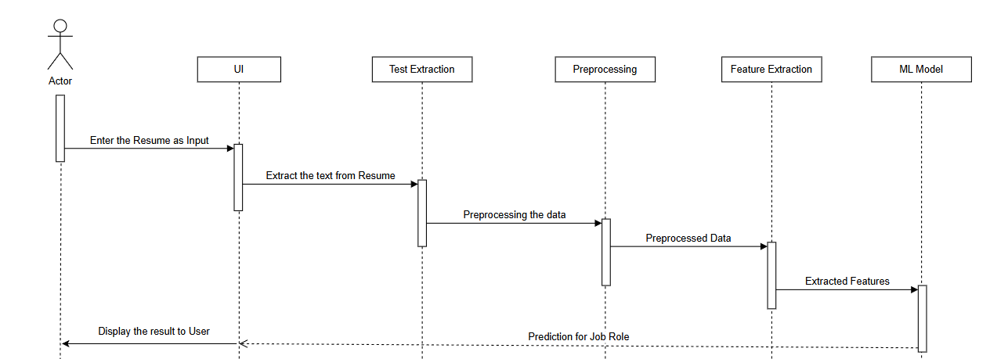

**Fig 4.3.3.1: Sequence diagram for System**

## Description:

Secquence diagram is usually represents a secquencing of evnts and the interaction between the various components of user in the system .the secquence is shown below.

#### Collaboration Diagram:

A collaboration diagram is represents a modeling object to the system of the associations that using between the object links.the interaction that object is definds the object.to identify the secquencce of the project is a number of placed of the next arrows this tool is convert into the collaboration diagram into a secquence of the some that secquence diagram.

#### Graphical Notation:

|  |  |  |
| --- | --- | --- |
| **Object** | symbolizes the relationship of coordination between objects. Objects within the system interact with one another. Shown as a rectangle within which lies the name of the object, preceded by a colon and underlined. |  |
| **Actor** | An actor is a nice guy, an artist who concentrates on his job. Actors interact with the relevant objects by sending a message to them. In a collaboration diagram, an actor is represented by a stick figure. |  |

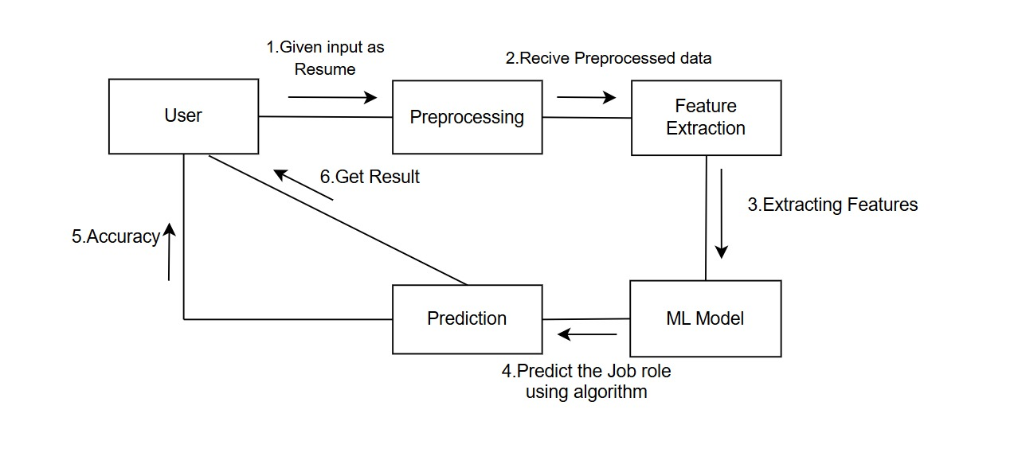**Fig 4. 4. 4.1 Collaboration Diagram for System**

#### Activity Diagram:

The process of this preprocessing process is usually moves that before being automatically transform thf following ,which is denoted by a round angle.

An arrow indicates the change from one activity to another. A system's actions are used to outline it in an activity diagram. The activities show a sequence of acts carried out in a particular order. They resemble data flow diagrams and flowcharts.

**Initial state:** this state is started the process?

##### Action State:

The execution of a fundamental action, which frequently entails calling an operation, is referred to as an action state. A simple state that has one exit transition and an entering action is referred to as an action state. The exit transition is the result of the implicit event that takes place once the entering action is completed.

Activity1

##### Transition:

The execution of a fundamental action, which frequently entails calling an operation, is referred to as an action state. A simple state that has one exit transition and an entering action is referred to as an action state. The exit transition is the result of the implicit event that takes place once the entering action is completed.

The relationship is a source of state and the target state is taken to as transision .itsstate that static state to anathor ,summarized

##### Final state:

A The final or "last" state of the surrounding composite state is indicated by a concluding state. The fact that multiple final states might exist at every level indicates that the composite state can conclude in a variety of scenarios. The entire are feasible once a final state is reached and there are no more enclosing states.

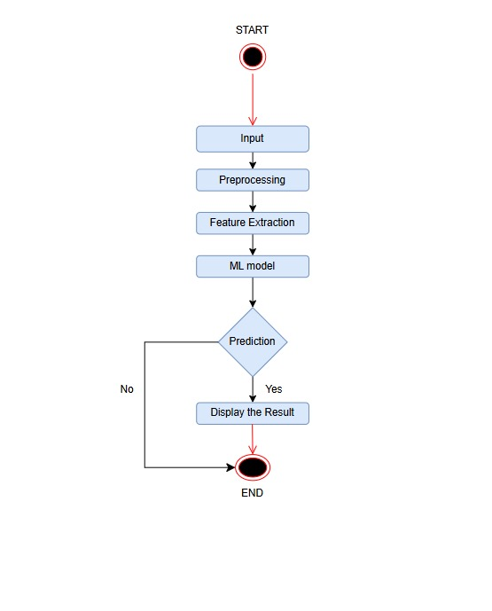

**Fig 4.4.5.1 Activity diagram for system**

# CHAPTER 5 TECHNOLOGY DESCRIPTION

## 5.TECHNOLOGY DESCRIPTION

#### Introduction to python

The definition of Python is: "A high-level interpreted programming language emphasizing code readability and simplicity". Guido van Rossum designed it and introduced it to the world in 1991. Python's design philosophy is to provide a clear and simple syntax that makes Python easy to work with and easier to learn. Its rapid growth in popularity is closely connected to its versatility and wide range of applications, from web development to data analysis, artificial intelligence, and scientific computing.



**Applications of python:**

Python is usually widely used language nowadays:

**Web Development**: Django and Flask, for example, are Python web frameworks that support scalable and robust web applications. The simplicity of Python and its extensive library support makes it popular among web developers.

**Data scince and machine learning :** Python has practically established itself as the language for data science and machine learning activities. Libraries like NumPy, Pandas, Matplotlib, and scikit-learn give the user powerful and efficient means for data manipulation, analysis, visualization, and machine learning.

**Scintific compution:** The computer languages used in science and engineering tend to be various, but Python is one of the most renowned. SciPy and NumPy provide an extensive collection of numerical methods, numerical tools, and capabilities for numerical computing, linear algebra, optimization, etc.

**Artificial intelligence and nlp techniques**: Multiple Python frameworks such as TensorFlow, Keras, and PyTorch have been used to design deep learning models and neural networks to be employed in AI applications. Their relative simplicity and robust library support offer Python a potent environment to work with natural language processing tasks.

**HISTORY OF PYTHON:**

Python was created by Guido van Rossum and released first in 1991. Guido van Rossum, a Dutch programmer, created Python after the ABC programming language. He wanted to design a language that places an emphasis on simplicity, readability, and the expressiveness of code. Python's development began as a side project for Guido van Rossum while working at the Centrum Wiskunde & Informatica (CWI) in the Netherlands. The initial focus was on improving the ABC language and addressing its limitations. Guido designed Python with a clear and concise syntax that made it easier to learn and use than other programming languages at the time.

Python is popular and stable through out the 1990s,driven and its simplicity ,variability and community supports .in 2000,python 2.0 was releged by several new features and improvements.

Python 3.0 (or Python 3000 or just Python 3) was made available for public use in the year 2008. It modified the semantics of the language in a backward-incompatible manner, thus creating a wall between the two: Python 2 and Python 3. Although the majority of the world continued using Python 2 for many years, that version reached its end of life in January 2020 - meaning it is no longer officially supported and maintained.

The 2010s have seen more and more success for Python due to its acceptance in many spheres: web development, data science, machine learning, and artificial intelligence. The availability of huge numbers of third-party libraries and frameworks such as NumPy, Pandas, Django, TensorFlow, and PyTorch have aided the success and adoption of Python.

Guido van Rossum served as the "Benevolent Dictator For Life" (BDFL) for the Python language until he resigned in 2018. The development of Python is now managed by the Python Software Foundation (PSF), a not-for-profit organization that supervises the language's development, standardization, and community efforts.

Because of its readability, library support, active online community, and various applications, Python is now one of the most popular and highly appreciated programming languages worldwide. Python is amenable to various applications such as web development, data analysis, scientific computing, and artificial intelligence.

**Python features :**

**Realibility:** python is having code realibility and uses a clean and straight forword syntax **.**the use of indentation is enough for white space makes the code easy to undesrstand the enhance its readibility

**Simplicity:**Python sims to be simple and good language for essy to learn snd use the python,poracticalluy for beginers**.**the syntax is designed to be clear and easy to read and write ,developers to express the lines of code is moving loe as compared the other code.

**Large stand library:** Python is accompanied by a thoroughly detailed standard library with a variety of modules and functions to assist in performing different tasks. The standard library includes file I/O for various works like networking, data manipulation, regular expressions, and many others with such comprehensive support; developers can perform a lot of tasks without external dependencies.

**Cross platform compactibility:**Python is the independent language of a platform. This means that a Python program can run on different operating systems, including Windows, macOS and Linux, without change. Portability lets developers write a code and use it across many platforms.

**Dynamic typing**: The late binding of the Python programming language makes it possible for the types of variables to be determined during runtime. Because of flexibility and speed, the developers won't need to declare the variable types, which will further increase the development cycles.

**Interpreted Language:** Python is an interpreted language, which means that code is executed line by line by the Python interpreter. This interpreted nature enables rapid prototyping and interactive development, where code changes can be tested and executed quickly.

**Object oriaanted support in python:** The computer language Python supports object-oriented programming paradigms, allowing programmers to create and use objects, classes, and inheritance. The OOP concepts of encapsulation, polymorphism, and abstraction can all be used in Python, resulting in code modularity and reusability.

**Extandability and readiability:** Incorporating modules written in other programming languages, such as C or C++, can easily extend python. Not only this, it simply allows one to take advantage of the existing libraries and code for the performance-critical areas. Python is also seamlessly integrated with other technologies and frameworks-in fact, some might say interoperability is the very definition of Python, explaining why it was designed to build complicated systems.

**Strong community and good eco system:** Within the field of Python, there exists a community of active developers, researchers, or enthusiasts. The community is also busy dedicating efforts to open-source contributions, documentation, and discussion forums, as well as organizing conferences and publicly available resources among fellow enthusiasts. With various third-party libraries and frameworks, Python is capable of expanding its competencies in web development, data science, machine learning, and so forth.

**Performance and scalability:**With the adoption of just-in-time compilation and bytecode, this interpreted language also gets a few optimizations. Python, through frameworks and libraries like NumPy and PyPy, makes efficient numerical computations and speed improvement possible, rendering them applicable in high-performance applications.

**Need of python:**

Python is a programming language and its highly demand and widely used for several resons:

Python is one of the most in-demand programming languages due to its simplicity, flexibility, and powerful ecosystem. It is especially useful in domains like data science, artificial intelligence, machine learning, web development, and automation.

Here’s why Python is needed:

* 🧠 **Ease of Learning**: Python has a straightforward syntax that closely resembles natural language, making it accessible even to beginners.
* 🧰 **Rich Libraries**: Libraries such as NumPy, Pandas, TensorFlow, Matplotlib, and Scikit-learn allow developers to implement complex tasks with minimal code.
* 🔁 **Cross-platform Compatibility**: Python code runs smoothly on various platforms including Windows, macOS, and Linux.
* ⚙️ **Rapid Prototyping**: Developers can build and test applications quickly, which is ideal for research and startups.
* 🔄 **Integration and Interoperability**: Python integrates well with other languages and systems, making it suitable for a wide range of applications.

In this project, Python plays a vital role in building the machine learning model, handling resume data, and deploying the web application using frameworks like **Flask**. Its simplicity, along with strong NLP and ML support, makes it the perfect choice for developing intelligent systems.

## Technologies Used:

#### Numpy:

#### It’s a fundemantal package for somputing in python language . its is mainly used for working with a arrays .its also has working on linear algebra and also matrices for this numpy is created by2005.

#### Numerical python:

A Python library includes a multidimensional array object, several derived objects (such as masked arrays and matrices), and a number of routines for fast array operations.

The ndarray object, which represents multi-dimensional arrays with elements of the same data type, is the foundation of NumPy. These arrays support high-performance operations, many of which are executed through optimized compiled code. Unlike Python lists that can change in size dynamically,

NumPy arrays are fixed in size once created. To modify their size, a new array must be formed, replacing the original. All elements within a NumPy array must share the same data type, which ensures consistent memory allocation. However, arrays of Python objects can be created to hold elements of varying types, though this is less common. NumPy arrays are designed for efficient computation, allowing complex mathematical operations to be executed on large datasets with less code and greater speed than native Python sequences. Due to their performance and versatility, NumPy arrays are widely adopted in numerous scientific and mathematical Python libraries.

#### Pandas :

The primary goal of the open-source Pandas library is to make working with relational or labeled data simple. It offers a range of operations and data structures for managing time series and numerical data.Pandas in Python is used by data scientists for a number of important reasons: In addition to using Data Frames for multi-dimensional datasets and Series for one-dimensional datasets, it effectively handles missing data.\

• It offers a useful method for slicing data.

• It offers a versatile method for combining, joining, or reshaping datasets.

Pandas is a robust data analysis library with robust time series tools. It can be applied to data analysis as well as manipulation. In addition, Pandas provides robust and easy-to-use data structures.

#### Matplotlib:

Matplotlib is a versatile and cross-platform library used in Python for creating visualizations and plotting data. It works closely with numPy and serves as a popular open-source alternative to MATLAB. Developers can use its APIs to integrate plots into graphical user interface (GUI) applications. A typical Matplotlib script requires only a few lines to create a visual representation of data. It offers two main interfaces: the pyplot module, which provides a simple, MATLAB-like way to generate plots, and an object-oriented API that offersgreater flexibility and control for advanced customization. The figure object is the top-level container for everything in a plot, while the axes object defines the area where data is displayed, including elements like lines, text, ticks, and axis labels

## Sklearn:

Scikit-learn is a Python library that is open-source and provides a unified interface for various algorithms related to machine learning, data pre-processing, crossvalidation, and visualization. Some key features of scikit-learn are:

• It offers user-friendly and powerful tools for data mining and analysis. It includes various algorithms for classification, regression, and clustering such as support vector machines, random forests, gradient boosting, and kmeans.

• This library is built on top of NumPy, SciPy, and matplotlib, making it adaptable for many applications and available to everyone. It is both opensource and suitable for commercial use. Before installing scikit-learn, ensure that you have both SciPy and NumPy. The easiest way to install scikit-learn is through pip, provided that you have a working copy of NumPy and SciPy.

**pip install -U scikit-learn**

## Seaborn:

A Python package called Seaborn is used to create statistical visualizations. It closely integrates with pandas data structures and builds upon matplotlib. Seaborn facilitates data exploration and comprehension. In order to create informative plots, its plotting functions work with data frames and arrays that contain entire datasets. They internally carry out the required statistical aggregation and semantic mapping.

## Spacy:

Spacy is a good and pewor ful natural language processing technique that analysis ,entity recocgination**.** It provides essential tools like word tokenization, tagging parts of speech, identifying sentence structure through dependency parsing, and recognizing entities within text. Known for its fast execution and reliable accuracy, spacy is well-suited for working with large datasets. It also features lemmatization, which simplifies words to their base forms, aiding in better data uniformity and improving model outcomes. Additionally, spacy includes ready-to-use language models that can be adapted for specialized use cases, making it a popular choice for applications such as categorizing text, detecting sentiment, and extracting key insights from raw language data.

## Re:

Python has a powerful tool for regular manifestations provided by RE modules, text cleaning and manipulation. They allow patterns-based discoveries, matching and replacing text, which makes them highly useful in preprosucting resumes to predict the job role. Using regular manifestations, unwanted characters, special symbols and irrelevant texts can be efficiently or modified, ensuring that only meaningful information for further analysis is maintained. They are particularly effective for tasks such as removing specific details from the resume, standardizing text formats, and handling the change in job title and details.

## NLTK:

NLTK is a comprehensive mainly librsry used for nlp techniques, including tokens, stopping removal, and steaming. Invlolves tolkenization breaking the text into different words or sentences, which helps to structures unnecessary re -starting data. Removing stopwords eliminate common words that do not contribute significantly to the meaning by improving computational efficiency and model performance. Steming reduces words in their original forms, which ensures stability in the word representation in the resume. The NLTK offers a wide range of tools and datasets that aids in the text preprising, making it a significant component in the re-launched job roll prediction system..

### INTRODUCTION TO MACHINE LEARNING

Machine Learning (ML) is a specialized area within Artificial Intelligence that focuses on enabling systems to learn from data and improve their performance without being explicitly programmed. Instead of relying on hardcoded instructions, ML models identify patterns, trends, and relationships within data to make informed predictions or decisions.

The learning process in ML typically begins with collecting and preparing data that reflects the problem space. This data is then used to train models by adjusting internal parameters to minimize prediction errors. The trained model is tested against unseen data to evaluate its ability to generalize and perform accurately in real-world scenarios.

There are three main types of machine learning:

* **Supervised Learning**: The algorithm learns from labeled data, where the correct output is provided. It is commonly used for classification and regression tasks.
* **Unsupervised Learning**: The algorithm works with unlabeled data, aiming to find hidden structures or groupings. Clustering and dimensionality reduction are common examples.
* **Reinforcement Learning**: The model learns through trial and error by interacting with an environment, receiving feedback in the form of rewards or penalties.

Machine learning has become essential in a wide range of applications such as resume screening, fraud detection, personalized recommendations, natural language processing, and autonomous systems. Its ability to process vast amounts of data and adapt to new information makes it a powerful tool in modern technology.

### ALGORITHM

Random Forest is a powerful machine learning algorithm commonly used for both classification and regression tasks. It belongs to the family of ensemble methods, which work by combining the predictions of multiple models to improve accuracy and reduce overfitting. In the case of Random Forest, it builds multiple decision trees during training and outputs the majority vote (for classification) or average (for regression) of their predictions.

One of the key strengths of Random Forest is its ability to handle high-dimensional data and complex relationships between variables. Each tree in the forest is trained on a random subset of the data and features, introducing diversity among the trees. This randomness helps the model to be more robust and reduces the chance of relying too heavily on any single feature or sample.

In the context of this project, Random Forest is used to predict suitable job roles by analyzing features extracted from resumes, such as skills, education, work history, and domain expertise. The model is trained using labeled data, allowing it to learn the patterns that correlate with specific job categories. Once trained, the model can generalize its understanding to unseen resumes, making accurate job role predictions.

The algorithm also provides insights into feature importance, helping to understand which resume attributes most influence the prediction. This makes Random Forest not only accurate but also interpretable, making it a suitable choice for real-world recruitment systems.

**Data preparation:**

Before training any machine learning model, the quality and structure of the input data play a critical role in determining its performance. In this project, resumes collected from various sources are first cleaned and organized to create a structured dataset. This process involves:

* Handling Missing Values: Filling in or removing incomplete data to ensure consistency.
* Removing Duplicates and Irrelevant Text: Cleaning up redundant or unnecessary information that may confuse the model.
* Standardizing Text: Converting all text to a consistent format (e.g., lowercase, punctuation removal).
* Feature Extraction: Isolating important components such as skills, education, experience, and domain keywords using natural language processing techniques.

These steps help ensure that the data fed into the model is clean, reliable, and meaningful, allowing the algorithm to focus on the most relevant attributes for job role prediction.

**Splitting data:**To train the Random Forest model effectively and evaluate its performance, the dataset is divided into multiple subsets. Typically, it is split into:

* **Training Set**: A portion of the data (usually 70-80%) used to train the model. It helps the algorithm learn the patterns and relationships within the data.
* **Testing Set**: The remaining data used to evaluate how well the model performs on unseen examples. This helps measure the generalization ability of the model.
* **Validation Set (Optional)**: Sometimes, an additional set is used during model development to tune parameters and avoid overfitting.

Splitting the data helps simulate real-world scenarios and ensures that the model is not just memorizing the input but actually learning meaningful patterns that it can apply to new resumes.

**Model Training:**Model training is the process where the Random Forest algorithm learns from the prepared data. Each decision tree in the forest is built by analyzing random subsets of features and training examples. During this phase, the model identifies relationships between the extracted features (like skills, education, and experience) and the corresponding job roles.

Each tree independently learns patterns from its subset, and their predictions are later combined to produce a final decision. This ensemble approach helps reduce errors caused by bias or overfitting. As more resumes are fed into the model, it continuously improves its ability to correctly predict job roles, ensuring high reliability and adaptability to diverse resume formats.

The model is trained using a labeled dataset that maps resumes to actual job roles. This supervised learning approach enables the model to understand which feature combinations are most relevant for specific career paths.

**Hyperparameter Tuning:** Hyperparameters are settings that control how a machine learning model behaves during training. In Random Forest, these include the number of trees, maximum depth of each tree, and the number of features to consider when splitting nodes.

Tuning these hyperparameters is essential to achieving the best performance. If the values are not optimized, the model might overfit (memorize data) or underfit (fail to learn enough patterns). In this project, techniques like **Grid Search** or **Randomized Search** are used to test different combinations of hyperparameters.

Each configuration is evaluated using validation data to check which one yields the highest accuracy. Once the best parameters are found, they are used to re-train the final model. This tuning process ensures the Random Forest classifier makes robust, accurate, and generalizable predictions.yes

**Model Evaluation:** After training the Random Forest model, it's crucial to evaluate how well it performs on unseen data. This is done using the testing set that was kept separate from training. The model’s predictions are compared with the actual job roles in this dataset to calculate performance metrics.

Key evaluation metrics include:

* **Accuracy**: The percentage of correct predictions made by the model.
* **Precision and Recall**: Useful for understanding how well the model identifies specific job roles.
* **F1 Score**: A balance between precision and recall, especially important in imbalanced datasets.

These metrics provide a comprehensive picture of the model’s performance, helping identify whether it can be trusted to make real-world predictions.

**Deployment and prediction:** Once the model is trained and tested successfully, the final step is deployment. This involves integrating the trained Random Forest model into a working application where it can accept real resumes and return job role predictions.

The system reads input resumes (in formats like PDF or DOCX), preprocesses the content, and extracts relevant features. These features are then passed through the trained model, which outputs the most suitable job role along with a brief explanation.

Deployment is done through a web application using **Flask**, allowing recruiters or job seekers to interact with the system in real-time. This ensures the model is not just a theoretical tool but a functional, user-friendly solution ready for practical use in hiring processes..

**HTML Introduction:**

HTML, the backbone of web page structure, employs a system of elements defined by tags to create the framework of a website. These tags, typically appearing in pairs as opening and closing, dictate how content is displayed, ranging from headings and paragraphs to links and images. The core structure of an HTML document is standardized, beginning with the declaration, followed by the , , and

tags, which respectively define thedocument type, the overall document, meta-information, and visible content. Attributes, embedded within opening tags, further refine these elements by providing additional details such as link destinations or image sources. Ethical learning of HTML emphasizes comprehension over mere copying; it involves understanding the function of each element and attribute, expressing this understanding through paraphrasing and summarization, and creating original examples. Regular practice, coupled with the use of browser developer tools for inspection, reinforces these principles, ensuring a solid and ethically sound grasp of HTML.

Hyperlinks are underlined or emphasized works that load to other documents or some portions of the same document. Html can be used to display any type of document on the host computer, which can be geographically at a different location. It is a versatile language and can be used on any platform or desktop. HTML provides tags (special code) to make the document look attractive. HTML provides or not case –sensitive. Using graphics, fonts, different sizes, colour, etc. can enhance the presentation of the document. Anything that is not a tag is part of the document itself.

**FLASK:**

Flask is a lightweight, flexible, and widely used web framework for Python, designed to build web applications and RESTful APIs efficiently. It follows the micro-framework approach, meaning it provides only the essential tools for web development, allowing developers to customize and extend functionality as needed. Unlike full-stack frameworks like Django, Flask does not come with built-in database management or authentication but allows seamless integration with third-party libraries. This makes Flask highly modular and adaptable for a wide range of applications.

One of Flask’s key features is its built-in development server, which allows developers to test applications locally before deployment. It also includes a powerful Jinja2 templating engine, which enables dynamic rendering of HTML pages. Flask’s URL routing system, defined using the @app.route() decorator, makes it easy to handle multiple endpoints, supporting both static and dynamic routes. Additionally, Flask provides an integrated debugger and error handling tools, making development more efficient by quickly identifying and resolving issues.

Flask is simple to install using pip install flask, and a basic application can be created with just a few lines of code. Developers can easily define routes, handle HTTP methods such as GET and POST, and process form data and JSON requests. Flask also supports session management and cookies, making it suitable for user authentication and stateful web applications.

Flask’s flexibility allows it to integrate with various databases using Flask-SQLAlchemy and work with API-focused extensions like Flask-RESTful. It is widely used for machine learning and data science applications, where developers deploy models as web-based services or build interactive dashboards. Flask is also commonly chosen for microservices architecture due to its lightweight nature and ease of deployment.

In addition to its scalability, Flask is beginner-friendly, making it a great choice for developers who want to learn web development without the complexity of larger frameworks. It is used by startups and enterprises alike, with companies such as Netflix and Airbnb incorporating Flask into their backend systems.

Overall, Flask is a powerful yet simple framework that balances ease of use with the flexibility to build complex applications. Its lightweight design, combined with robust extensibility, makes it a popular choice for developers working on everything from small projects to large-scale applications. Whether used for building APIs, deploying machine learning models, or developing full-fledged web applications.

# CHAPTER 6 SAMPLE CODE

### SAMPLE CODE

#### App.py ( Execute the process )

import pickle

from flask import Flask, request, jsonify, render_template

import fitz  # PyMuPDF for PDF extraction

import pdfplumber

import docx9

import pandas as pd

import joblib

import re

import nltk

import os

from nltk.corpus import stopwords

from nltk.tokenize import word_tokenize

from sklearn.feature_extraction.text import TfidfVectorizer

from sklearn.pipeline import Pipeline

from sklearn.ensemble import RandomForestClassifier

nltk.download("punkt")

nltk.download("stopwords")

app = Flask(__name__, static_folder='static')

# Function to preprocess text

def preprocess_text(text):

    text = text.lower()

    text = re.sub(r'[^a-zA-Z\s]', '', text)

    words = word_tokenize(text)

    stop_words = set(stopwords.words("english"))

    words = [word for word in words if word not in stop_words]

    return " ".join(words)

# Load skills from an external file

def load_skills():

    skills_file = "skills.txt"

    if not os.path.exists(skills_file):

        return []

    with open(skills_file, "r") as f:

        skills = [line.strip() for line in f.readlines()]

    return skills

# Function to extract skills from text

def extract_skills(text):

    skills_list = load_skills()

    words = re.findall(r'\b\w+\b', text.lower())

    return list(set(skill for skill in skills_list if skill.lower() in words))

# Function to generate explanation for a predicted job role

def generate_explanation(job_role):

    explanations = {

        "Software Engineer": "Strong programming skills in Python, Java, or C++. Experience with frameworks such as Django, Flask, or Spring Boot.",

        "Data Scientist": "Expertise in machine learning, data analysis, and tools like TensorFlow, PyTorch, and Scikit-learn.",

        "DevOps Engineer": "Experience with DevOps tools like Docker, Kubernetes, AWS, and CI/CD pipelines.",

        "Product Manager": "Project management skills with Agile methodologies, Jira, and strong stakeholder communication.",

        "Full Stack Developer": "Expertise in both front-end and back-end technologies including JavaScript, React, Node.js, and Django.",

        "AI/ML Engineer": "Experience in AI, deep learning, NLP, TensorFlow, PyTorch, and model deployment.",

        "Cybersecurity Analyst": "Knowledge of penetration testing, security audits, risk management, and tools like Wireshark.",

        "Cloud Engineer": "Experience with AWS, Azure, Google Cloud, Kubernetes, and Terraform.",

        "Business Analyst": "Data-driven decision-making, SQL, Power BI, Tableau, and market research.",

        "UI/UX Designer": "Proficiency in Figma, Adobe XD, wireframing, and front-end design principles."

    }

    return explanations.get(job_role, "Role assigned based on matching relevant skills and experience.")

# Load Dataset

def load_dataset():

    if not os.path.exists("dataset.csv"):

        return None

    df = pd.read_csv("dataset.csv")

    df["resume_text"] = df["resume_text"].astype(str).apply(preprocess_text)

    return df

df = load_dataset()

if df is None:

    raise Exception("Dataset file not found!")

# Load Trained Model

def load_model():

    if not os.path.exists("job_role_model.pkl"):

        return None

    return joblib.load("job_role_model.pkl")

model = load_model()

if model is None:

    raise Exception("Model file not found!")

# Function to extract text from PDF resumes

def extract_text_from_pdf(pdf_path):

    text = ""

    try:

        with pdfplumber.open(pdf_path) as pdf:

            for page in pdf.pages:

                extracted = page.extract_text()

                if extracted:

                    text += extracted + "\n"

    except Exception as e:

        return str(e)

    return text.strip() if text.strip() else "No text found in PDF."

# Function to extract text from DOCX resumes

def extract_text_from_docx(docx_path):

    try:

        doc = docx.Document(docx_path)

        return "\n".join([para.text for para in doc.paragraphs if para.text.strip()])

    except Exception as e:

        return str(e)

@app.route('/')

def home():

    return render_template('index.html')

@app.route('/predict', methods=['POST'])

def predict():

    if 'file' not in request.files:

        return jsonify({"error": "No file uploaded"})

    uploaded_file = request.files['file']

    file_type = uploaded_file.filename.split(".")[-1]

    file_path = f"uploaded_resume.{file_type}"

    uploaded_file.save(file_path)

    extracted_text = extract_text_from_pdf(file_path) if file_type == "pdf" else extract_text_from_docx(file_path)

    if not extracted_text.strip():

        return jsonify({"error": "No text extracted from resume"})

    skills = extract_skills(extracted_text)

    if not skills:

        return jsonify({"message": "No skills detected", "job_role": "None", "explanation": "No job role predicted due to lack of extracted skills."})

    processed_text = preprocess_text(extracted_text)

    predicted_role = model.predict([processed_text])[0]

    role_explanation = generate_explanation(predicted_role)

    return jsonify({"skills": skills, "predicted_job_role": predicted_role, "explanation": role_explanation})

if __name__ == '__main__':

    app.run(debug=True)

**2 USER IMTERFACE:**

<!DOCTYPE html>

<html lang="en">

<head>

    <meta charset="UTF-8">

    <meta name="viewport" content="width=device-width, initial-scale=1.0">

    <link rel="stylesheet" href="{{ url_for('static', filename='style.css') }}">

    <title>Resume based job role predicton</title>

</head>

<body>

    <div class="container">

        <h1>Resume Based Job Role predicton</h1>

        <form id="upload-form" action="/predict" method="post" enctype="multipart/form-data">

            <input type="file" name="file" required>

            <br>

            <button type="submit">Upload</button>

        </form>

        <div id="output" class="output" style="display: none;">

            <h2>Extracted Skills</h2>

            <p id="skills"></p>

            <h2>Predicted Job Role</h2>

            <p id="job_role"></p>

            <h2>Explanation</h2>

            <p id="explanation"></p>

        </div>

    </div>

    <script>

        document.getElementById("upload-form").onsubmit = async function(event) {

            event.preventDefault();

            const formData = new FormData(this);

            const response = await fetch("/predict", {

                method: "POST",

                body: formData

            });

            const result = await response.json();

            if (result.error) {

                alert(result.error);

            } else {

                document.getElementById("skills").innerText = result.skills.join(", ") || "No skills detected.";

                document.getElementById("job_role").innerText = result.predicted_job_role || "No job role predicted.";

                document.getElementById("explanation").innerText = result.explanation || "No explanation available.";

                document.getElementById("output").style.display = "block";

            }

        };

    </script>

</body>

</html>

**3 STYLE.CSS**

body {

    background: url("resume.jpg") no-repeat center center fixed;

    background-size: cover;

    font-family: Arial, sans-serif;

    color: #333;

    text-align: center;

    margin: 0;

    padding: 0;

}

.container {

    width: 50%;

    margin: auto;

    padding: 20px;

    background: #222;

    color: #f4f4f4;

    border-radius: 10px;

    box-shadow: 0px 4px 8px rgba(0, 0, 0, 0.2);

    margin-top: 50px;

}

h1 {

    color: #1ddd30;

}

button {

    margin-top: 25px;

    background-color: #1ddd30;

    color: white;

    padding: 10px 20px;

    border: none;

    border-radius: 10px;

    cursor: pointer;

    font-size: 16px;

}

button:hover {

    background-color: #45a049;

}

input[type="file"] {

    margin-top: 10px;

}

form {

    margin-top: 20px;

}

label {

    font-weight: bold;

}

#### 4 accuracy.ipynb(Importing dataset and libraries)

# Import necessary libraries

import pandas as pd

import joblib

import re

import nltk

import pdfplumber

import docx

import seaborn as sns

import matplotlib.pyplot as plt

from wordcloud import WordCloud

from nltk.corpus import stopwords

from nltk.tokenize import word_tokenize

from sklearn.feature_extraction.text import TfidfVectorizer

from sklearn.pipeline import Pipeline

from sklearn.ensemble import RandomForestClassifier

# Download NLTK resources

nltk.download("punkt")

nltk.download("stopwords")

# Set visualization style

sns.set_style("darkgrid")

plt.rcParams["figure.figsize"] = (10, 6)

def load_dataset():

df = pd.read_csv("dataset.csv")

return df

df = load_dataset()

df.head()

**resume_textjob_role**0software development Python Git Django Java C++Software Engineer1data science machine learning deep learning Te...Data Scientist2Docker Kubernetes AWS DevOps Terraform CI/CDDevOps Engineer3Scrum Agile roadmap JIRA leadershipProduct Manager4Python C++ Java software development Django GitSoftware Engineer

# Function to preprocess text

def preprocess_text(text):

    text = text.lower()

    text = re.sub(r'[^a-zA-Z\s]', '', text)

    words = word_tokenize(text)

    stop_words = set(stopwords.words("english"))

    words = [word for word in words if word not in stop_words]

    return " ".join(words)

# Load Dataset

def load_dataset():

    df = pd.read_csv("dataset.csv")

    df["resume_text"] = df["resume_text"].astype(str).apply(preprocess_text)

    return df

df = load_dataset()

# Display dataset overview

print("Dataset Head:")

print(df.head())

print("\nDataset Info:")

print(df.info())

Dataset Head:

resume_text job_role

0 software development python git django java c Software Engineer

1 data science machine learning deep learning te... Data Scientist

2 docker kubernetes aws devops terraform cicd DevOps Engineer

3 scrum agile roadmap jira leadership Product Manager

4 python c java software development django git Software Engineer

Dataset Info:

<class 'pandas.core.frame.DataFrame'>

RangeIndex: 1000 entries, 0 to 999

Data columns (total 2 columns):

# Column Non-Null Count Dtype

--- ------ -------------- -----

0 resume_text 1000 non-null object

1 job_role 1000 non-null object

dtypes: object(2)

memory usage: 15.8+ KB

None

# Load Trained Model

def load_model():

    return joblib.load("job_role_model.pkl")

model = load_model()

# Function to extract text from PDF resumes

def extract_text_from_pdf(pdf_path):

text = ""

try:

with pdfplumber.open(pdf_path) as pdf:

for page in pdf.pages:

extracted = page.extract_text()

if extracted:

text += extracted + "\n"

except Exception as e:

return str(e)

return text.strip() if text.strip() else "No text found in PDF."

# Function to extract text from DOCX resumes

def extract_text_from_docx(docx_path):

    try:

        doc = docx.Document(docx_path)

        return "\n".join([para.text for para in doc.paragraphs if para.text.strip()])

    except Exception as e:

        return str(e)

# Function to predict job role

def predict_job_role(resume_text):

processed_text = preprocess_text(resume_text)

predicted_role = model.predict([processed_text])[0]

return predicted_role

# Example usage

sample_resume = "Experience in Python, machine learning, and data analysis using TensorFlow and Scikit-learn."

predicted_role = predict_job_role(sample_resume)

print("Predicted Job Role:", predicted_role)

Predicted Job Role: Data Scientist

# Visualization: Word Cloud of Most Frequent Words in Resumes

all_words = ' '.join(df["resume_text"])

wordcloud = WordCloud(width=800, height=400, background_color='white').generate(all_words)

plt.figure(figsize=(10, 5))

plt.imshow(wordcloud, interpolation="bilinear")

plt.axis("off")

plt.title("Word Cloud of Resume Data")

plt.show()

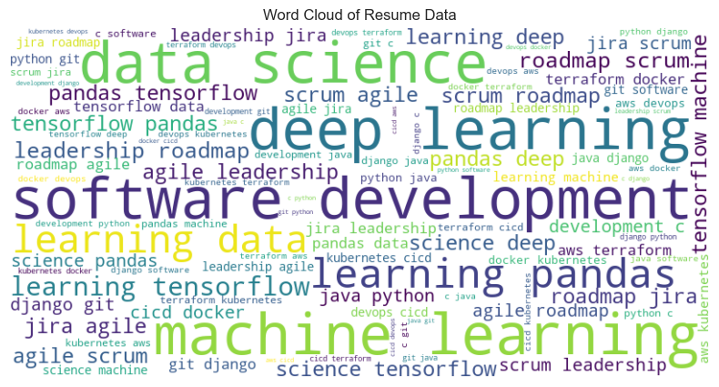

feature_importances = model.named_steps['clf'].feature_importances_

feature_names = model.named_steps['tfidf'].get_feature_names_out()

importance_df = pd.DataFrame({"Feature": feature_names, "Importance": feature_importances})

importance_df = importance_df.sort_values(by="Importance", ascending=False).head(20)

plt.figure(figsize=(12, 6))

sns.barplot(x=importance_df["Importance"], y=importance_df["Feature"])

plt.title("Top 20 Important Features for Job Role Prediction")

plt.show()

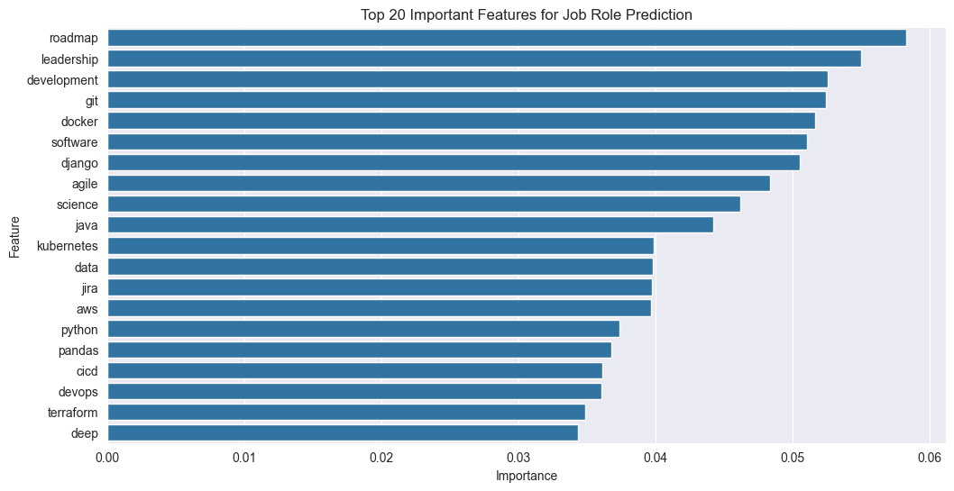

# Visualization: Job Role Distribution

if "job_role" in df.columns:

    plt.figure(figsize=(10, 5))

    sns.countplot(y=df["job_role"], order=df["job_role"].value_counts().index, palette="coolwarm")

    plt.title("Job Role Distribution in Dataset")

    plt.xlabel("Count")

    plt.ylabel("Job Role")

    plt.show()

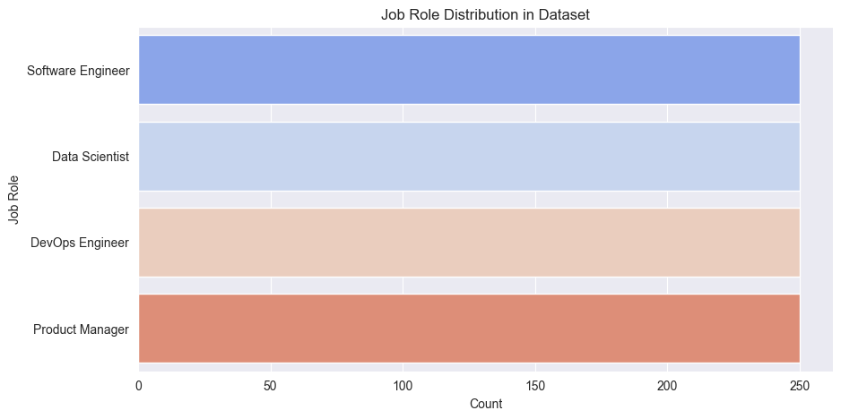

# Visualization: Resume Text Length Distribution

df["text_length"] = df["resume_text"].apply(lambda x: len(x.split()))

plt.figure(figsize=(10, 5))

sns.histplot(df["text_length"], bins=30, kde=True, color="blue")

plt.title("Distribution of Resume Text Length")

plt.xlabel("Number of Words in Resume")

plt.ylabel("Frequency")

plt.show()

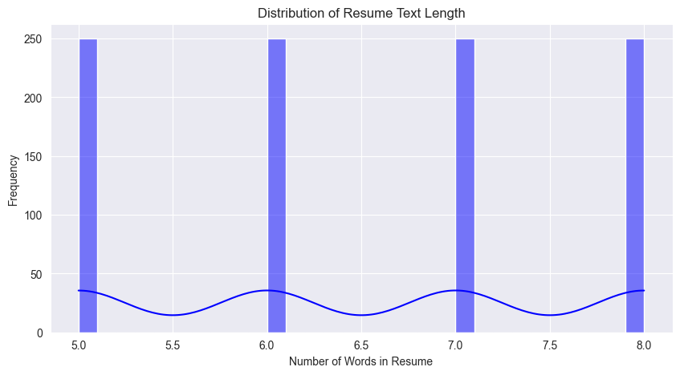

from sklearn.model_selection import train_test_split

X_train, X_test, y_train, y_test = train_test_split(

    df["resume_text"], df["job_role"], test_size=0.2, random_state=42

)

vectorizer = TfidfVectorizer()

classifier = RandomForestClassifier(n_estimators=200, random_state=42)

pipeline = Pipeline([

    ('tfidf', vectorizer),

    ('clf', classifier)

])

pipeline.fit(X_train, y_train)

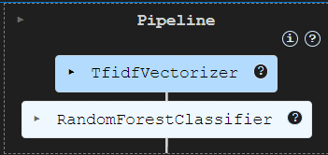

from sklearn.metrics import accuracy_score, classification_report, confusion_matrix

import seaborn as sns

import matplotlib.pyplot as plt

# Predict on test data

y_pred = model.predict(X_test)

# Classification report

print("\nClassification Report:")

print(classification_report(y_test, y_pred))

Classification Report:

precision recall f1-score support

Data Scientist 1.00 1.00 1.00 54

DevOps Engineer 1.00 1.00 1.00 52

Product Manager 1.00 1.00 1.00 49

Software Engineer 1.00 1.00 1.00 45

accuracy 1.00 200

macro avg 1.00 1.00 1.00 200

weighted avg 1.00 1.00 1.00 200

from sklearn.feature_extraction.text import TfidfVectorizer

from sklearn.neighbors import KNeighborsClassifier

from sklearn.metrics import accuracy_score

# Convert text features into numerical format

vectorizer = TfidfVectorizer()

X_train_tfidf = vectorizer.fit_transform(X_train.astype(str))  # Convert to string

X_test_tfidf = vectorizer.transform(X_test.astype(str))

# Initialize and train KNN classifier

clf = KNeighborsClassifier()

clf.fit(X_train_tfidf, y_train)

# Make predictions

y_pred = clf.predict(X_test_tfidf)

accuracy = accuracy_score(y_test, y_pred)

print("Model Accuracy:", accuracy)

Model Accuracy: 1.0

import matplotlib.pyplot as plt

import seaborn as sns

from wordcloud import WordCloud

# Plot distribution of job roles

plt.figure(figsize=(10, 5))

sns.countplot(y=df['job_role'], order=df['job_role'].value_counts().index, palette="viridis")

plt.title("Distribution of Job Roles")

plt.xlabel("Count")

plt.ylabel("Job Role")

plt.show()

# Generate a word cloud of resume text

text = " ".join(df["resume_text"])

wordcloud = WordCloud(width=800, height=400, background_color="white").generate(text)

plt.figure(figsize=(10, 5))

plt.imshow(wordcloud, interpolation="bilinear")

plt.axis("off")

plt.title("Word Cloud of Resume Text")

plt.show()

# Confusion Matrix

from sklearn.metrics import confusion_matrix, ConfusionMatrixDisplay

cm = confusion_matrix(y_test, y_pred)

disp = ConfusionMatrixDisplay(confusion_matrix=cm, display_labels=pipeline.classes_)

disp.plot(cmap="viridis", values_format="d")

plt.title("Confusion Matrix")

plt.show()

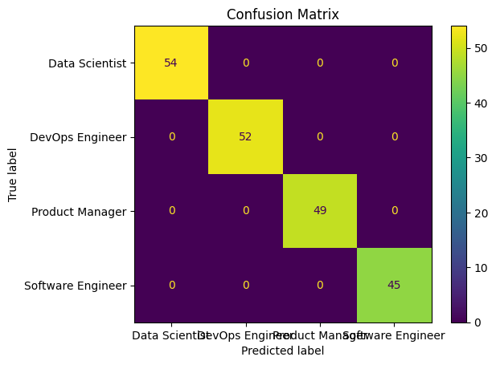

# Encoding Categorical Data

label_encoder = LabelEncoder()

df['job_role_encoded'] = label_encoder.fit_transform(df['job_role'])

# Text Feature Extraction using TF-IDF Vectorizer

tfidf = TfidfVectorizer(max_features=3000, ngram_range=(1,2))  # Using bigrams for better feature extraction

X = tfidf.fit_transform(df['resume_text']).toarray()

y = df['job_role_encoded']

# Handling Imbalanced Data using SMOTE

smote = SMOTE(random_state=42)

X, y = smote.fit_resample(X, y)

# Splitting Data into Training and Testing Sets

X_train, X_test, y_train, y_test = train_test_split(X, y, test_size=0.2, random_state=42)

# Model Training and Evaluation

models = {

    "Logistic Regression": LogisticRegression(max_iter=1000, solver='saga', class_weight='balanced', random_state=42),

    "SVM": SVC(kernel='rbf', class_weight='balanced', random_state=42),

    "Random Forest": RandomForestClassifier(n_estimators=300, class_weight='balanced', random_state=42)

}

accuracies = {}

for name, model in models.items():

    model.fit(X_train, y_train)

    y_pred = model.predict(X_test)

    accuracies[name] = accuracy_score(y_test, y_pred)

    print(f"{name} Accuracy: {accuracies[name]:.4f}")

Logistic Regression Accuracy: 1.0000

SVM Accuracy: 1.0000

Random Forest Accuracy: 1.0000

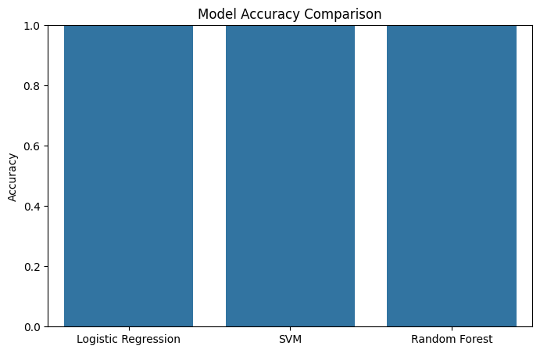

## 

## CHAPTER 7 TESTING

### 7.TESTING

#### 7.1 Introduction

#### Testing is a critical in software development that involvs evaluating a system to get this functions as intended meets the requirements and produce the results. Prime goal is testing is to identify defects,errors,or behaviour in order to improve the quality and realibility of the software.testing the performed at different levels of software developments ,including unit testing ,intregration testing ,system testing ,and accepence testing .each levels of focusing on specific ascepts of the software and iams to unware different tyoes of issues.

#### System testing and implementation

system testing is a level of software testing that focuses on evaluating the complete and integrated system to ensure its compliance with specified requirements and objectives. It is performed after unit testing and integration testing and before the software is deployed to the end-users. Verifying the system's overall functionality, performance, dependability, and security is the main goal of system testing.

The goals, scope, test scenarios, and test cases to be carried out are outlined in the system test plan. The plan also contains information about the resources needed for testing, the test environment, and the test data. All required hardware, software, and network configurations are present in the test environment. By doing this, the testing environment is guaranteed to be very similar to the production environment where the system will be used. The test plan is followed when executing the system test cases. Input validation, data manipulation, error handling, performance, scalability, and security are just a few of the functional and non-functional aspects of the system that are covered by these test cases.

Any flaws or departures from the expected behavior are found and recorded while the test case is being executed. The development team is informed of defects along with pertinent details, including how to replicate them and the expected and actual outcomes. The development team resolves the problems and fixes the defects that have been reported. To make sure that the flaws have been successfully fixed without creating new problems, the impacted areas are retested after the fixes are put into place.

Performance testing is one type of system testing that can be used to assess how responsive, scalable, and resource-efficient the system is under both typical and high load scenarios. To find possible bottlenecks or performance problems, performance metrics are measured and compared to predetermined criteria. Security testing is conducted to assess the system's resilience against potential security vulnerabilities and threats. To guarantee the integrity and confidentiality of the system, it entails testing for authorization, authentication, data protection, and other security controls.

The system is presented to stakeholders or end users for approval after undergoing extensive testing and meeting the established requirements. To confirm that the system satisfies user needs and operates as anticipated in practical situations, user acceptance testing, or UAT, may be carried out.   
In software development, implementation is the process of putting the system or software into the production environment so that end users can use it. It entails setting up the required hardware and software components, installing the software, and making sure the system is up and running.

The version or build to be deployed, as well as any related documentation, release notes, or user manuals, are specified in the release plan. The infrastructure, software, and hardware required for deployment are ready. This could entail configuring servers, databases, network setups, and security protocols. The deployment plan is followed when installing the system or software in the production environment. This could entail initializing databases, setting up settings, and copying files.

Existing data from legacy systems may be transferred to the new system if appropriate. During the migration process, this entails data transfer, data format transformation, and data integrity assurance. The system is set up according to the particular needs of the company or end users. This entails configuring system preferences, user accounts, access permissions, and other configuration parameters. The system undergoes testing and validation following deployment to make sure it operates as intended in the real-world setting. To make sure the system is prepared for use, this may entail executing test scenarios, confirming the accuracy of the data, and carrying out last-minute checks.

#### Testing Techniques

The methods or approaches used to plan and carry out tests to guarantee the dependability and quality of software systems are known as testing techniques. Various testing methods are used to find flaws, confirm functionality, and confirm that the system complies with requirements. The following are a few popular testing methods.

##### Black Box Testing

Black box testing ignores the system's internal organization and implementation specifics in favor of concentrating on the system's external behavior. Test cases are created using the requirements, specifications, and anticipated functionality of the system as a guide. Testers validate the system based only on inputs and expected outputs; they are not aware of the inner workings of the system.

##### White Box Testing

White box testing, sometimes referred to as structural or glass box testing, looks at the system's internal organization and operation. To guarantee that every code path, branch, and logic in the system is thoroughly tested, test cases are created. This method, which frequently incorporates strategies like code coverage analysis, necessitates familiarity with the internal operations of the system.

#### Testing Strategies

##### Unit Testing:

The goal of unit testing is to verify that code implementation is correct by testing individual functions, methods, or modules separately to make sure they behave as intended. Unit testing is carried out at the smallest testable unit of the system, usually at the code level.

##### Integration Testing:

Integration testing confirms how various system modules or components interact and depend on one another. It guarantees proper operation and efficient communication between the integrated components. This method aids in locating integration problems like mismatched interfaces, inconsistent data, or poor communication.

##### Regression Testing:

After changes or improvements are made, regression testing entails retesting the system or the impacted areas. It guarantees that the modifications won't adversely affect already-existing functionality. Regression testing aids in identifying unexpected consequences or flaws brought about by code modifications.

##### Performance Testing:

Performance testing evaluates how well the system operates and behaves under various load scenarios. It seeks to gauge the system's response times, throughput, scalability, and resource usage. Techniques for performance testing include endurance, stress, and load testing.

##### Security Testing:

Vulnerabilities and weaknesses in the system's security mechanisms are found through security testing. It entails testing for input validation, data protection, authorization, authentication, and other security measures. Commonly employed methods include vulnerability scanning, penetration testing, and security code reviews.

##### Functional Testing:

Functional tests provide that functions tested are available as specified by the business and technical requirements,system documentations , and user manuals.

Functional testing is centered on the following items

|  |  |
| --- | --- |
| Valid Input | : it will be valid output must be accepted |
| Invalid Input | : The test caseds will be must be regected. |
| Functions | : identified functions must be exercised. |
| Output | : identified classes of application outputs must be exercised. |
| Procedures | : interfacing systems or procedures must be invoked. |

#### Sample Test Cases Specifications

|  |  |  |  |  |
| --- | --- | --- | --- | --- |
| **Test case id no** | **User input** | **Expected output** | **Observed output** | **Result** |
| **T1** | Given Resume as input | Given Resume is Extracted | Text will be Extracted | Pass |
| **T2** | For Given resume, predicting job role by ML | Job Role Prediction | Job role Prediction is Given | Pass |

**Table 7.2.1: Sample Test Case Specification**

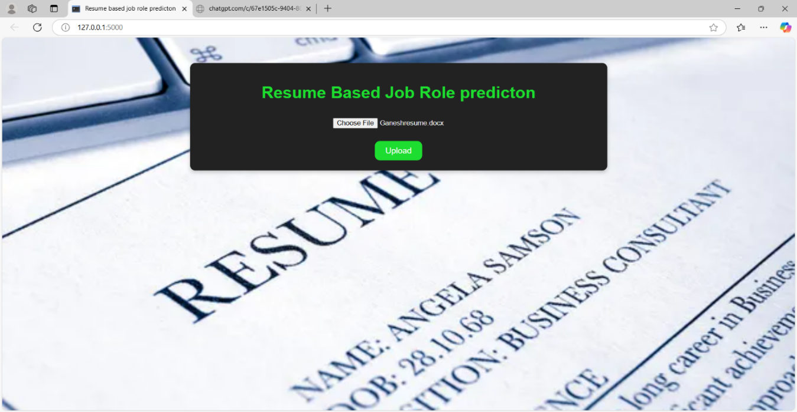

**Test Case 1:** **Given Resume as input**

**Description:** The resume-based job role prediction system takes a candidate's resume as input, extracts relevant skills and experience, and predicts the most suitable job role. It then provides a detailed job role description, including responsibilities, required skills, and salary insights

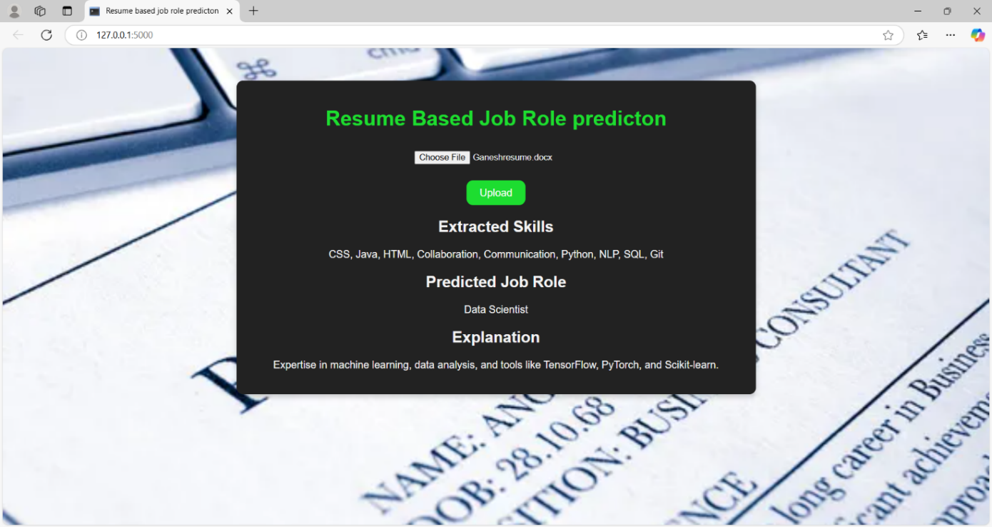

**Test case 2: For Given resume, predicting job role by ML**

**Description:** The Resume-Based Job Role Prediction System is an application that processes a candidate’s resume to extract skills, experience, and education and predict the most suitable job role. It then generates a detailed job description based on the prediction, helping job seekers understand their best-fit roles and employers filter candidates efficiently.

# CHAPTER 8 SCRENSHOTS

### SCREENSHOTS

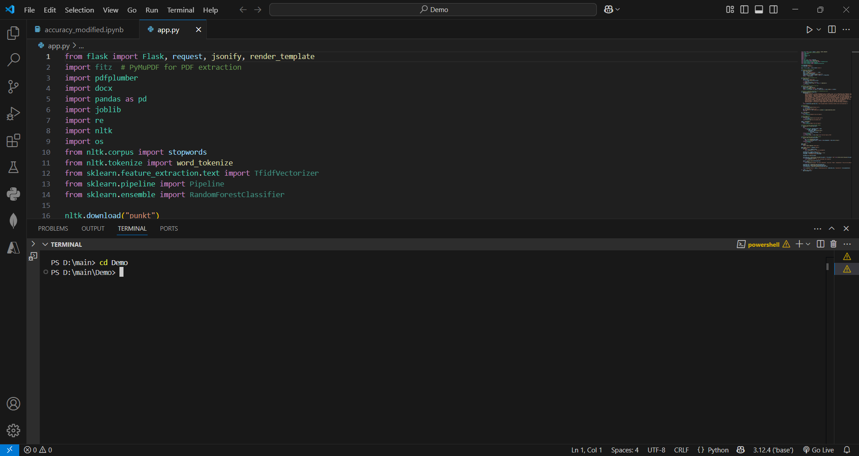

**Fig 8.1 Set the path to execute**

**Description:** Here I give a command as ‘cd new’ in the terminal which is used to set the path.

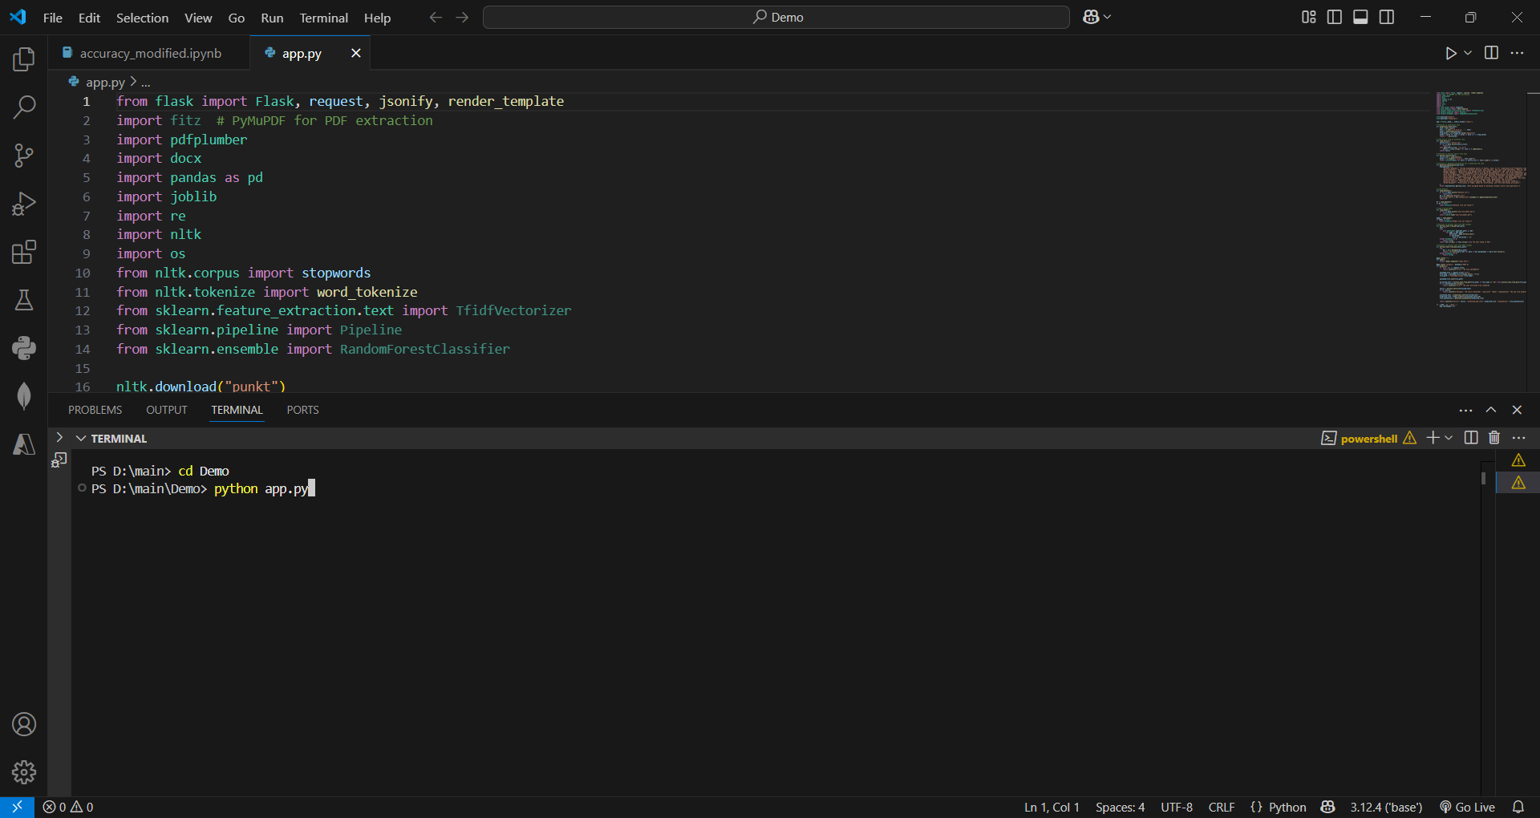

**Fig 8.2 Execute the main code**

**Description:** Here I use the command as ‘python app.py’ to execute the main code.

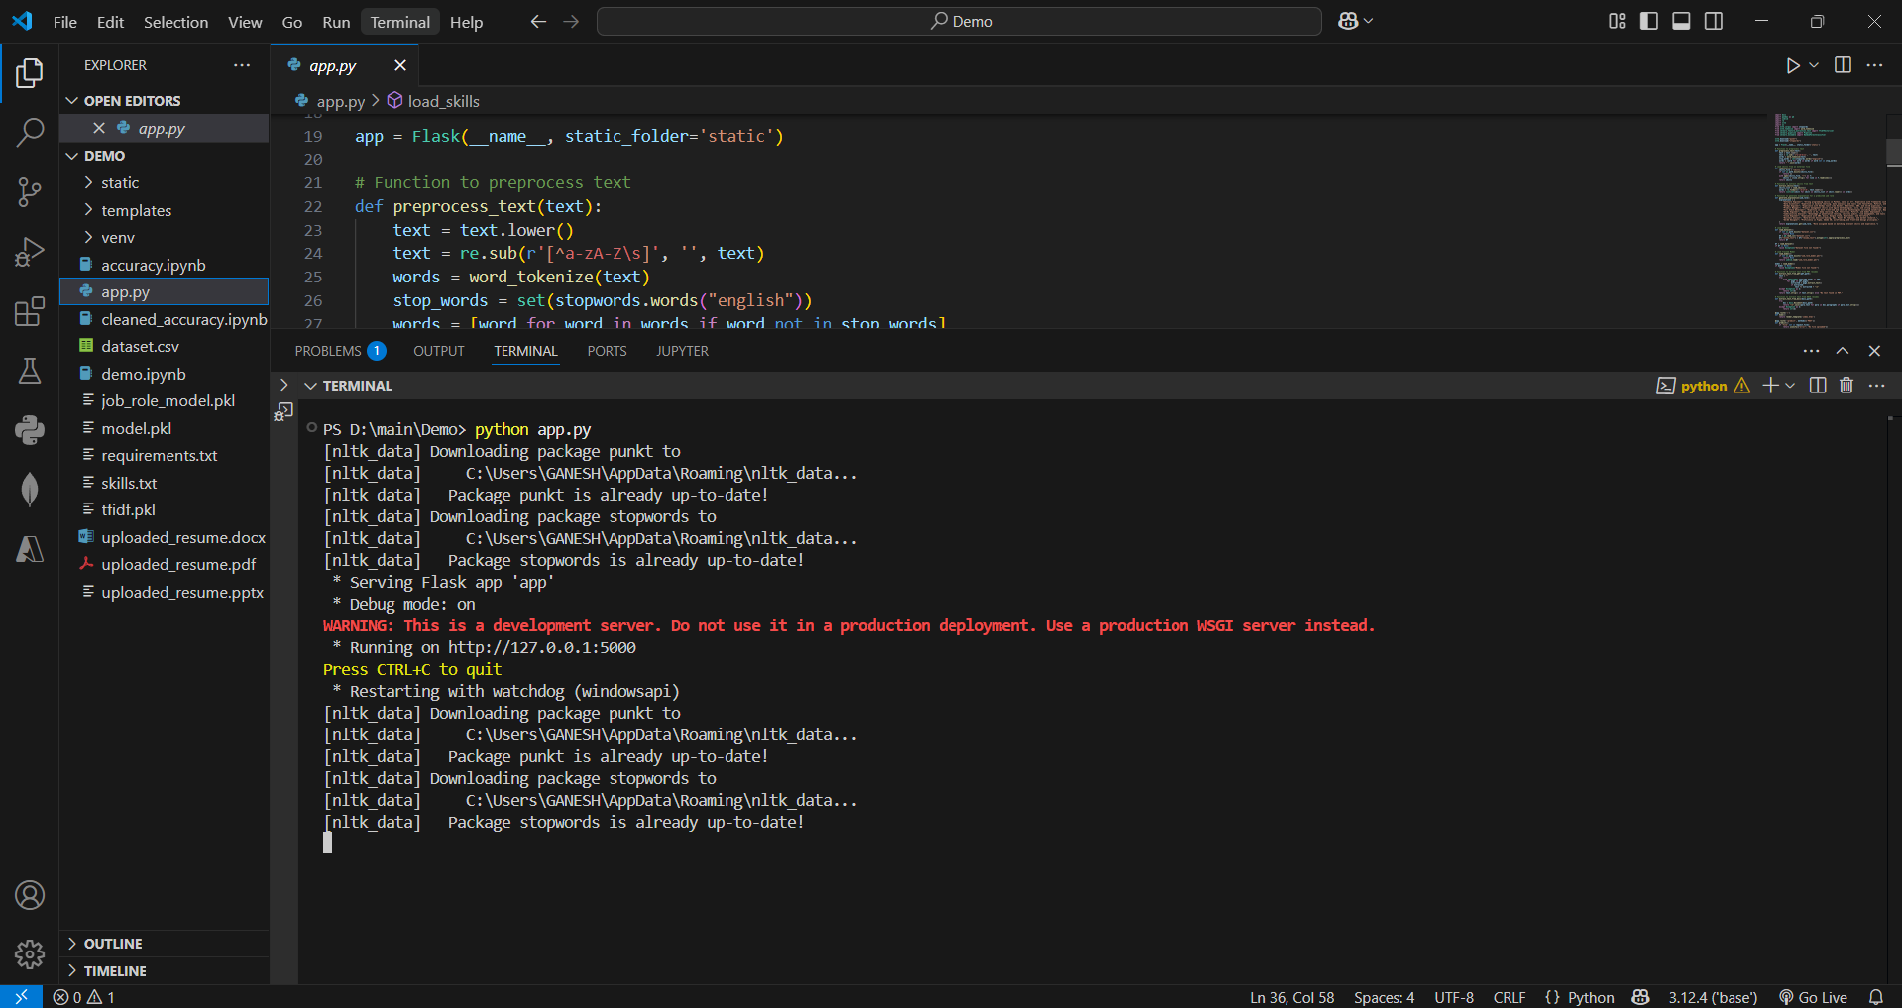

**Fig 8.2 Executed in Browser**

**Description:** Here I use the command as ‘python app.py’ to execute the main code in Browser.

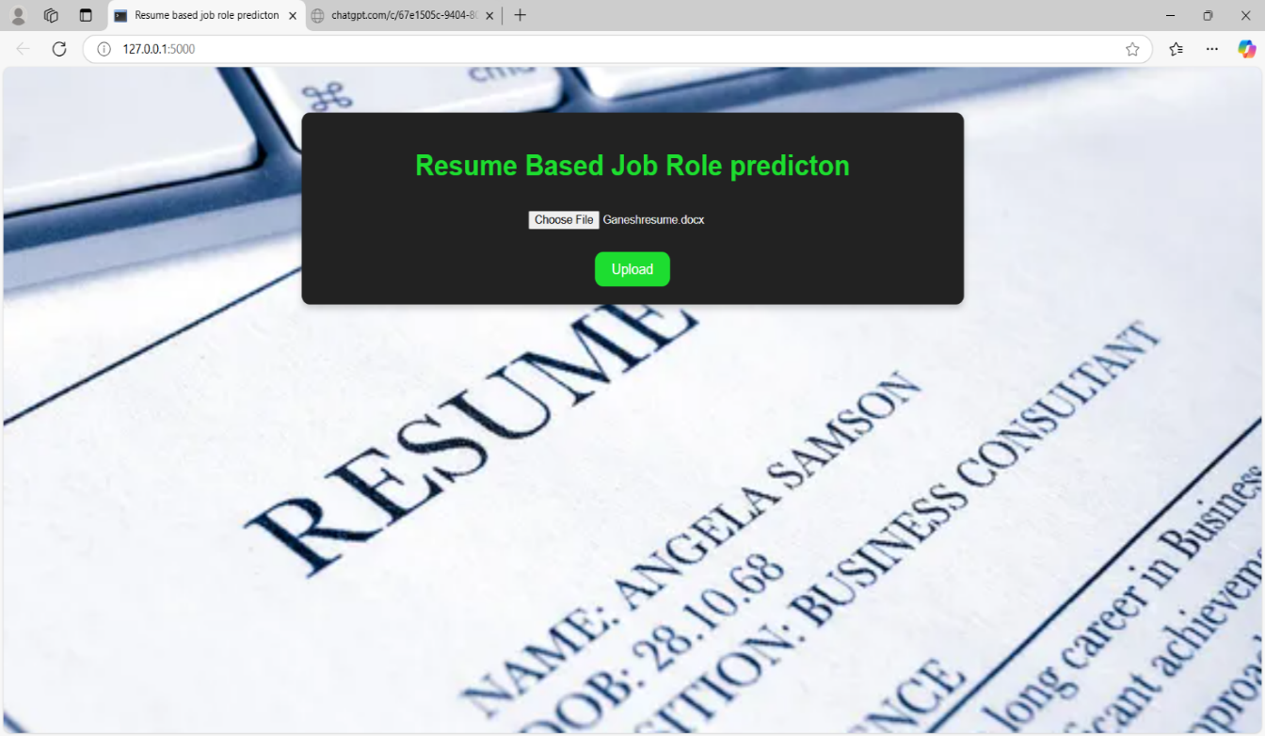

**Fig 8.3 User interface 1**

**Description:** When I execute the command python app.py it will process and gives an user interface.

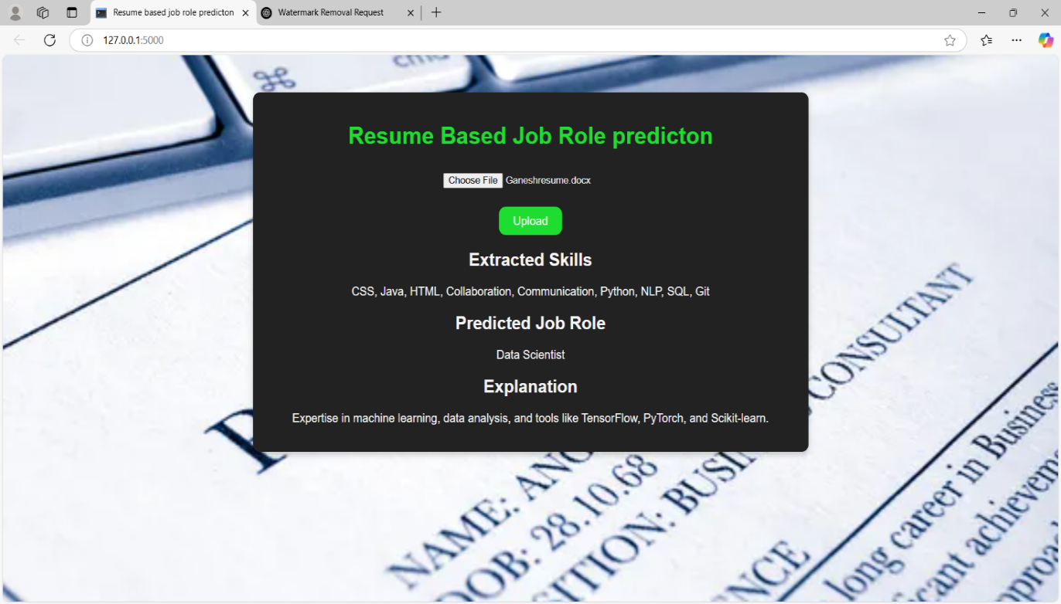

**Fig 8.4 User interface 2**

**Description**: while giving some right inputs it shows the result sample is potable

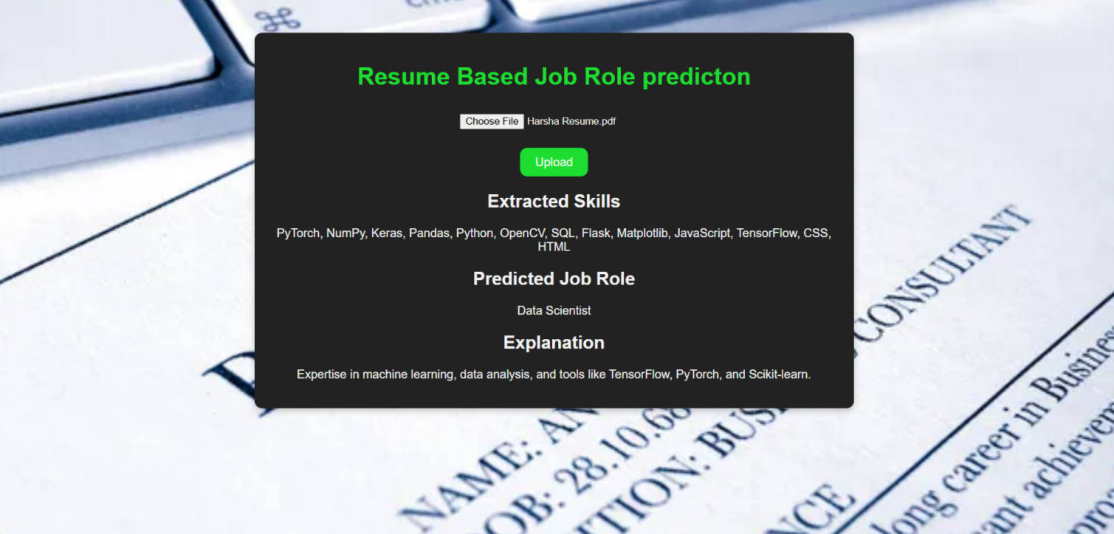

**Fig 8.5 Result Page 2**

**Description**: While in giving the resume it shows the loading the resume, And give the output as data scientist.

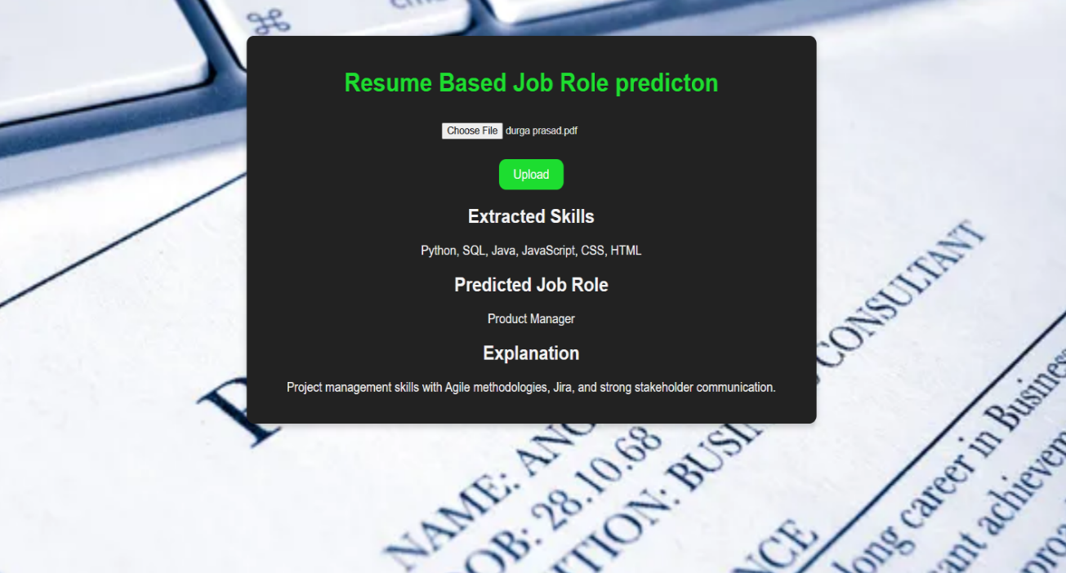

**Fig 8.5 Result Page 3**

**Description**: While im giving the resume it shows the loading the resume, And give the output as Product manager.

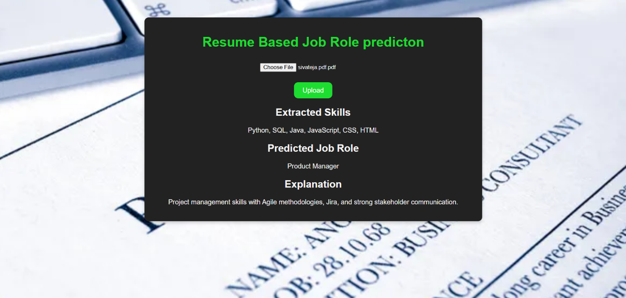

**Fig 8.5 Result Page 4**

**Description**: While im giving the resume it shows the loading the resume. And give the output as Product manager.

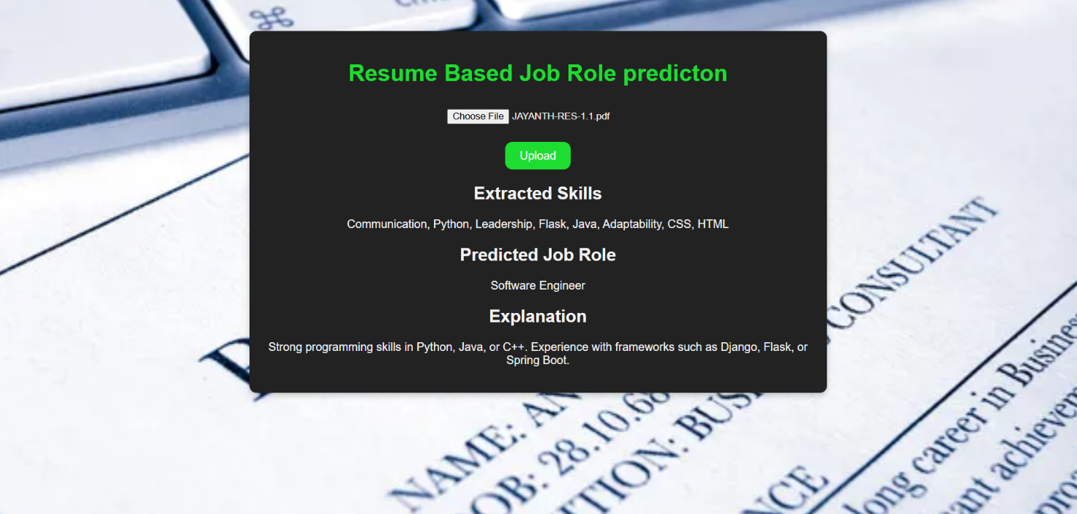

**Fig 8.5 Result Page 5**

**Description**: While im giving the resume it shows the loading the resume. And give the output as software engeneer.

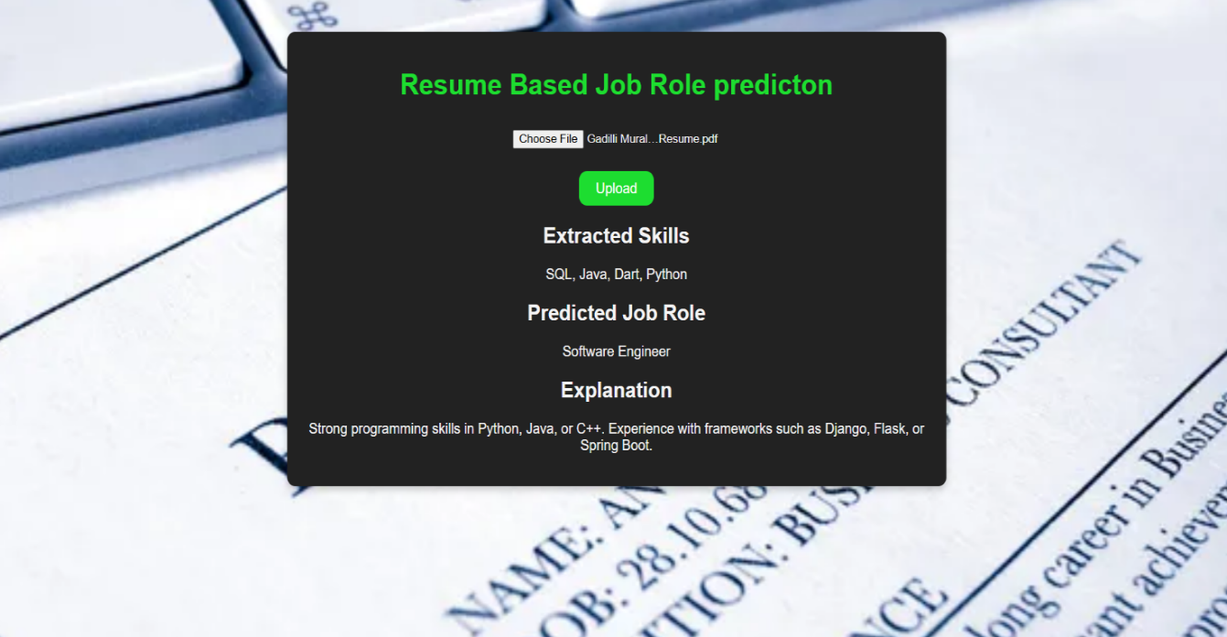

**Fig 8.5 Result Page 6**

**Description**: While im giving the resume it shows the loading the resume, And give the output as Software engineer.

### CONCLUSION

This study examines an alternative machine learning approach to predict job roles based on re -introduced data using random forest. Traditionally, the job role classification requires manual analysis, which is time consuming and subjective. This research major uses supervised machine learning algorithms to automatically analyze the re -introduction features of the job. The model helps to streamline recruitment by suggesting appropriate job roles, reducing human efforts and improving the efficiency of hiring. By taking advantage of future analytics, this approach enhances talent acquisition and career recommendations.

#### Future scope:

* The model aims to achieve high accuracy in predicting job role.
* Additional resumed parameters, such as certificates, project experience and skills, can be included to increase prediction performance.
* The system is the user friendly and accessible, even for individuals without technical expertise.

### BIBLIOGRAPHY

#### Book Referred:

* 1. Python programming : a modern approach by vamsi Kurama,pearson.
  2. Learning python by MARK KUTZ,Orielly.
  3. Introduction to machine learning with python by andru c.muller and srash Gudio, oreilly
  4. Hands on machine learning woth sk learn ,tensorflow and keras by aureelian Georn,oreilly.

#### Websites referred:

1. Wikipedia, URL: [https://en.wikipedia.org](https://en.wikipedia.org/)
2. Google, URL: [http://www.google.co.in.](http://www.google.co.in/)
3. For Python & Machine Learning: https://[www.javatpoint.com](http://www.javatpoint.com/)

#### References:

1. Sanyal, Satyaki, et al. ‘Resume Parser with Natural Language Processing.” International Journal of Engineering Science, 44-84 (2017).
2. Shivratri, Pooja, et al. ‘Resume Parsing and Standardization.” Inter-national Journal of Computer Sciences and Engineering 3.3, 129-131 (2015).
3. Chandola, Divyanshu, et al. ‘Online resume Parsing System using

Text Analytics” Journal of Multi Disciplinary Engineering Technologies, 9.1 (2015)

[4] Ibrahim, Aneesha T., et al. ‘Resume Parser.’ International Journal of

Innovations in Engineering and Technology, 11.1 (2018)